09
Time Series Modeling and Forecasting of Price Ratio of Two Stocks
MAFS513 Final Project

CHAN Chun Wang, Aaron
NEE Jingjing, Frank
WANG Suyi
WANG Zhiyuan
YOU Jianshu, Himmel

Introduction 2
Data Description 2
The Company – China Light & Power 2
The Company – Hong Kong Electric Holdings 4
Correlated rate of return of the two stocks 5
Modeling and Forecasting 6
Behind the model 10
Preliminary Trading Strategy 10
Improvements 11
Range Forecast Based Trading 11
STDev Prediction with GARCH Model 11
Volume Adjustment 14
Conclusion and Future Work 15
Appendix 15

Introduction
Single stock return is affected strongly by fundamental factors. For example, bank stocks are affected by interest rate while oil stocks are affected by oil price. Such factors are actually changing every day, and so they are continuously giving shocks to the related stock price. However, if a trader buys a stock and short sells another stock which has very similar business, he will be able to avoid such kind of risks.
Let and be the price of two stocks at time t, then the log return of these two stocks from t-1 to t should be and . So if a trader buys stock P and short sells stock Q at t-1 by same notional amount, his log return from t-1 to t would be
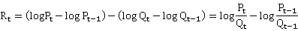
If we construct a price ratio , the return of the strategy is just the log return of the price ratio. So our time series model will focus on this ratio and try to forecast this ratio. If the forecasted ratio is larger than the current one, we buy stock P and short sells stock Q, and vice versa. The position will be reviewed daily according to the new forecasting. And very importantly, the notional of our long/short sides should be adjusted to same amount everyday to make sure the return of next period is still exactly equal to the return of the price ratio.

Data Description
In this project, the two stocks we choose are China Light & Power (0002.HK) and HK Electric (0006.HK). Both of them are providing electric in HK. CLP runs the business in Kowloon and New Territories, while HKE does on HK Island. The two companies have been listed since 1986, so they provide us enough data for the research.
We choose weekly return (Friday to Friday) as objects. The reason is that the daily return is relatively small for pair trading, considering the trading cost. Using weekly return, we only need to adjust our position once a week. We take total 331 weeks, from the first week in 2003 to the first week in May 2009.

The Company – China Light & Power
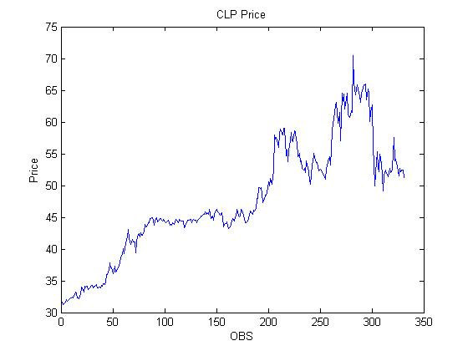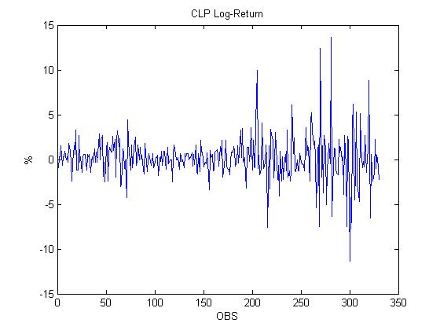
The Stock Price and Log-Return of CLP
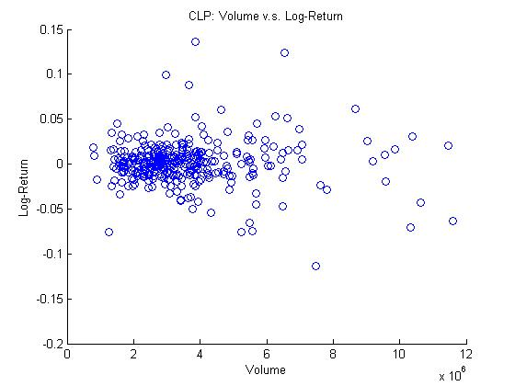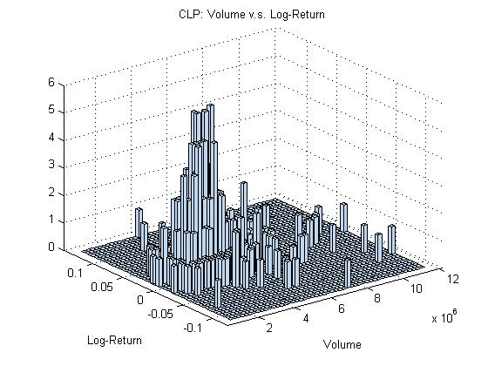
The Log-Return v.s. Volume of CLP
It is expected to see that the stock price movement (demonstrated by abs_log_return) is highly correlated to the trading volume (). It can be seen that the correlation coefficient is , and the p-value < 0.0001 is less than the 0.05 significance level. Hence the null hypothesis that the two variables are not correlated is rejected. This shows that the two variables are positively correlated. The trading volume doesn’t provide much information on the direction of price movement (). Here the p value is 0.4538 > 0.05, hence the null hypothesis H0: ρ=0 is not rejected and it can be concluded that the log return and the volume are not correlated.
Simple Statistics
Variable N Mean Std Dev Sum Minimum Maximum
log_return1 330 0.00147 0.02468 0.48453 -0.11381 0.13658
abs_log_return1 330 0.01624 0.01862 5.35820 0 0.13658
vol1 331 3593940 1854528 1189594000 788500 11608200
Pearson Correlation Coefficients
Prob > |r| under H0: Rho=0
Number of Observations
log_ abs_log_
return1 return1 vol1

log_return1 1.00000 0.12165 -0.04137
0.0271 0.4538
abs_log_return1 0.12165 1.00000 0.54366
0.0271 <.0001
vol1 -0.04137 0.54366 1.00000
0.4538 <.0001

However, when considering the absolute value of the log return against the trade volume, one obtains a positive correlation:

It can be seen that there is a positive correlation between the absolute value of the log return and the volume have a positive correlation, with ρ = 0.54366, and a p-value <0.0001, which is less than the 0.05 significance level. Hence the null hypothesis H₀: ρ=0 is rejected.

The Company – Hong Kong Electric Holdings
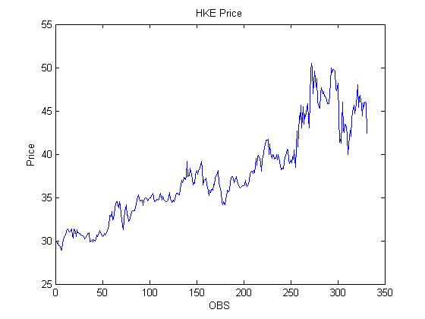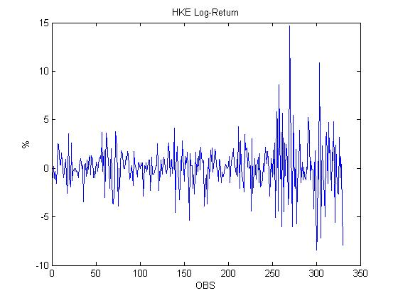
The Stock Price and Log-Return of HKE
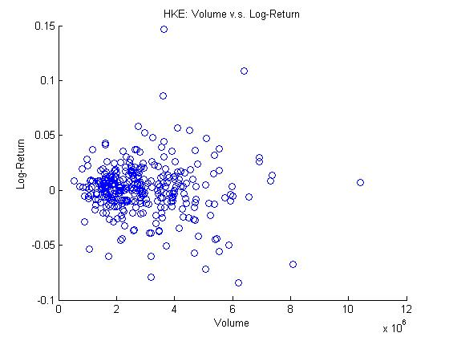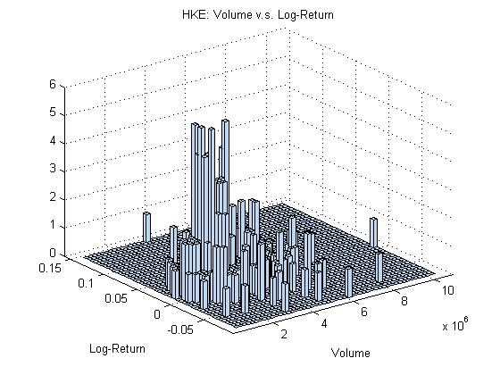
The Log-Return v.s. Volume of HKE

Simple Statistics
Variable N Mean Std Dev Sum Minimum Maximum
log_return2 330 0.00105 0.02403 0.34595 -0.08437 0.14681
abs_log_return2 330 0.01624 0.01773 5.35790 0 0.14681
vol2 331 2917161 1446220 965580400 526300 10416600
Pearson Correlation Coefficients
Prob > |r| under H0: Rho=0
Number of Observations
log_ abs_log_
return2 return2 vol2
log_return2 1.00000 0.09026 -0.12156
0.1017 0.0272
abs_log_return2 0.09026 1.00000 0.49818
0.1017 <.0001
vol2 -0.12156 0.49818 1.00000
0.0272 <.0001
As with CLP, a similar conclusion can be drawn about HKELECTRIC. The log returns are not correlated with the volume, so the volume does not indicate any directionality. However, the absolute log returns are positively correlated with the volume, indicating that big price moves accompany large volumes.

Correlated rate of return of the two stocks
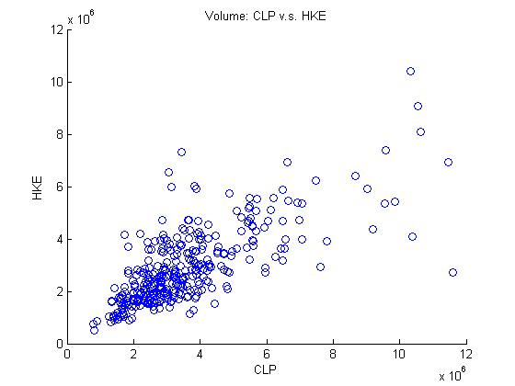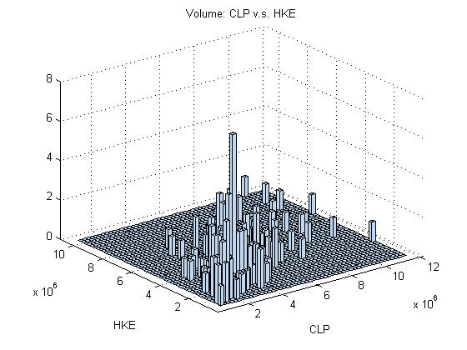
Volume: CLP v.s. HKE
Simple Statistics
Variable N Mean Std Dev Sum Minimum Maximum
vol1 331 3593940 1854528 1189594000 788500 11608200
vol2 331 2917161 1446220 965580400 526300 10416600
Pearson Correlation Coefficients, N = 331
Prob > |r| under H0: Rho=0
vol1 vol2
vol1 1.00000 0.72695
<.0001
vol2 0.72695 1.00000
<.0001
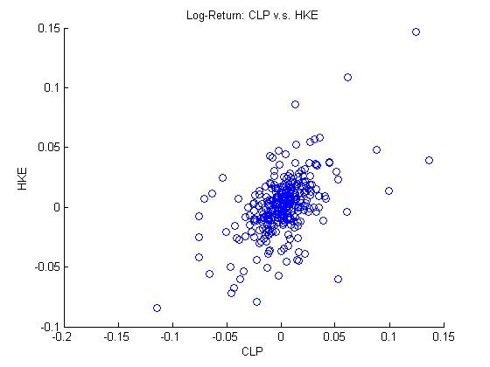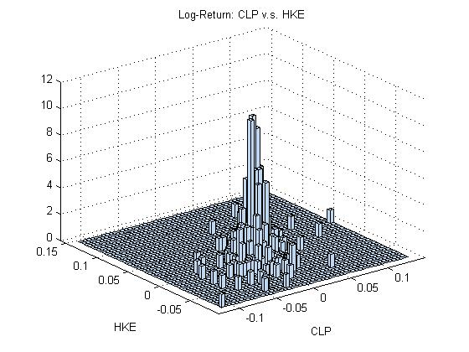
Log-Return: CLP v.s. HKE

It can be seen that there is a strong positive correlation between the volume of the two stocks. The correlation coefficient is 0.72695, with a p value <0.05. Hence the null hypothesis that ρ=0 is rejected. This result is expected, as all stocks traded on the Hang Seng Index should have positive correlations between their trading activities.
Simple Statistics
Variable N Mean Std Dev Sum Minimum Maximum
log_return1 330 0.00147 0.02468 0.48453 -0.11381 0.13658
log_return2 330 0.00105 0.02403 0.34595 -0.08437 0.14681
Pearson Correlation Coefficients, N = 330
Prob > |r| under H0: Rho=0
log_ log_
return1 return2
log_return1 1.00000 0.53629
<.0001
log_return2 0.53629 1.00000
<.0001
The correlation analysis supports our former assumption that these two stocks are highly correlated as they are of the same industry sector. The correlation coefficient is . The p-value <0.0001<005, hence one rejects the null hypothesis that ρ = 0.

Modeling and Forecasting
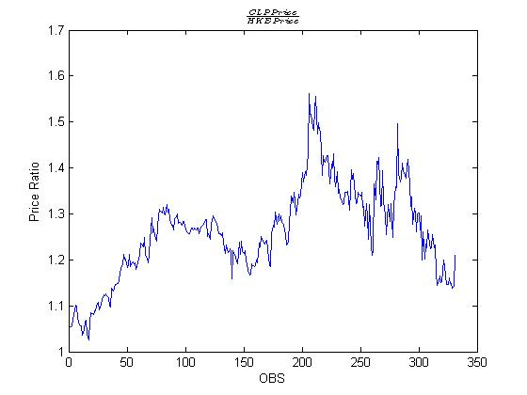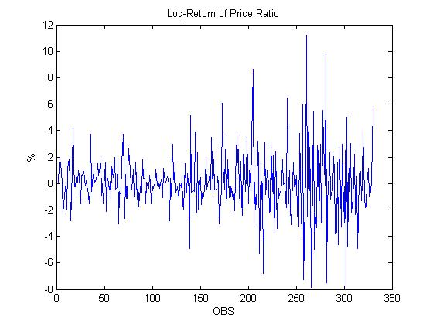
Price ratio
It is known that the stock price is generally notstationary, but the log-return is. The stock price ratio shares the similar case, as is demonstrated above. We try fit the log-return of price ratio into ARMA(p,q) model.
The ARIMA Procedure
Name of Variable = log_ratio_return
Mean of Working Series 0.00042
Standard Deviation 0.023426
Number of Observations 330
Autocorrelations
Lag Covariance Correlation -1 9 8 7 6 5 4 3 2 1 0 1 2 3 4 5 6 7 8 9 1 Std Error
0 0.00054880 1.00000 | |********************| 0
1 -0.0001411 -.25703 | *****| . | 0.055048
2 6.98485E-6 0.01273 | . | . | 0.058572
3 -0.0000313 -.05710 | .*| . | 0.058581
4 -0.0000127 -.02320 | . | . | 0.058749
5 -0.0000187 -.03409 | .*| . | 0.058777
6 0.00002576 0.04694 | . |*. | 0.058837
7 2.62167E-6 0.00478 | . | . | 0.058950
8 3.32553E-6 0.00606 | . | . | 0.058951
9 -0.0000292 -.05328 | .*| . | 0.058953
10 3.02983E-8 0.00006 | . | . | 0.059099
11 6.91059E-7 0.00126 | . | . | 0.059099
12 -0.0000132 -.02400 | . | . | 0.059099
13 -9.9269E-6 -.01809 | . | . | 0.059128
14 0.00002885 0.05257 | . |*. | 0.059145
15 4.20972E-6 0.00767 | . | . | 0.059287
16 1.25321E-6 0.00228 | . | . | 0.059290
17 2.57106E-8 0.00005 | . | . | 0.059290
18 0.00004969 0.09055 | . |** | 0.059290
19 -0.0000533 -.09720 | **| . | 0.059707
20 0.00004795 0.08738 | . |** | 0.060185
21 -0.0000362 -.06591 | .*| . | 0.060568
22 0.00004245 0.07734 | . |** | 0.060785
23 -0.0000643 -.11712 | **| . | 0.061083
24 0.00005091 0.09277 | . |** | 0.061759

Partial Autocorrelations
Lag Correlation -1 9 8 7 6 5 4 3 2 1 0 1 2 3 4 5 6 7 8 9 1
1 -0.25703 | *****| . |
2 -0.05711 | .*| . |
3 -0.07339 | .*| . |
4 -0.06139 | .*| . |
5 -0.06493 | .*| . |
6 0.01532 | . | . |
7 0.01436 | . | . |
8 0.00711 | . | . |
9 -0.05229 | .*| . |
10 -0.02710 | .*| . |
11 -0.00592 | . | . |
12 -0.03591 | .*| . |
13 -0.04576 | .*| . |
14 0.02984 | . |*. |
15 0.02938 | . |*. |
16 0.01238 | . | . |
17 0.00701 | . | . |
18 0.10661 | . |** |
19 -0.03978 | .*| . |
20 0.06322 | . |*. |
21 -0.02664 | .*| . |
22 0.06212 | . |*. |
Minimum Information Criterion
Lags MA 0 MA 1 MA 2 MA 3 MA 4 MA 5
AR 0 -7.51108 -7.57416 -7.55939 -7.54859 -7.53237 -7.51543
AR 1 -7.56491 -7.55683 -7.54238 -7.53128 -7.51493 -7.4988
AR 2 -7.5542 -7.54481 -7.5282 -7.51378 -7.49736 -7.48278
AR 3 -7.54486 -7.53114 -7.5137 -7.49623 -7.48368 -7.46731
AR 4 -7.53134 -7.51472 -7.49718 -7.48029 -7.46746 -7.45018
AR 5 -7.51778 -7.50048 -7.48317 -7.4657 -7.45062 -7.43373
Error series model: AR(5)
Minimum Table Value: BIC(0,1) = -7.57416
The Autocorrelations seem to decay exponentially, as do the partial autocorrelations. This suggests a MA(1) model. The ACF and BIC also confirm that the MA(1) model has the minimum information criterion. The MLE estimation gives the following result.

Maximum Likelihood Estimation
Standard Approx
Parameter Estimate Error t Value Pr > |t| Lag
MU 0.0003675 0.0008806 0.42 0.6764 0
MA1,1 0.29339 0.05328 5.51 <.0001 1
Constant Estimate 0.000368
Variance Estimate 0.000511
Std Error Estimate 0.022614
AIC -1562.26
SBC -1554.67
Number of Residuals 330
Correlations of Parameter
Estimates
Parameter MU MA1,1
MU 1.000 -0.010
MA1,1 -0.010 1.000
Autocorrelation Check of Residuals
To Chi- Pr >
Lag Square DF ChiSq --------------------Autocorrelations--------------------
6 3.63 5 0.6042 0.008 -0.005 -0.071 -0.052 -0.036 0.040
12 5.37 11 0.9122 0.014 -0.004 -0.057 -0.019 -0.016 -0.031
18 9.73 17 0.9145 -0.010 0.056 0.028 0.021 0.033 0.083
24 17.18 23 0.8002 -0.056 0.060 -0.038 0.044 -0.087 0.058
30 22.92 29 0.7801 -0.029 0.057 -0.017 -0.025 -0.096 -0.040
36 35.64 35 0.4382 0.057 0.126 -0.035 -0.085 -0.082 0.015
42 40.35 41 0.4993 0.055 0.017 0.005 -0.008 -0.087 0.038
48 51.51 47 0.3016 0.022 0.115 -0.088 0.061 -0.048 -0.039
Model for variable log_ratio_return
Estimated Mean 0.000368
Moving Average Factors
Factor 1: 1 - 0.29339 B**(1)
Here it can be seen that the residuals are white noise. All the Chi-Squared values for lags from 6 to 48 are greater than the 0.05 significance level. Hence the null hypothesis of the Ljung-Box test, is not rejected. This is a good model.
The MA(1) model is written as:
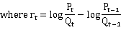
The forecast is done with respect to this MA(1) model, with the results shown below.
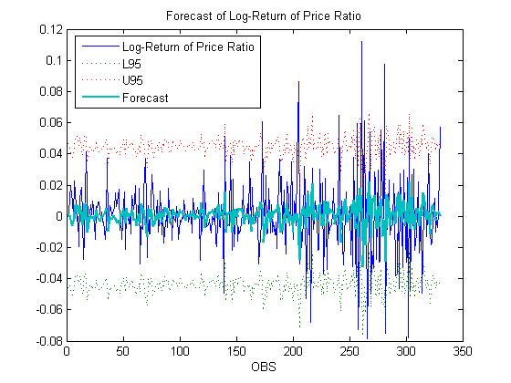
Forecast of Log-Return of Price Ratio

Behind the model
In this MA(1) model for the log-return of the price ratio, we see that the Lag-1 ACF is -0.25703, which demonstrates negative correlation between and . It can be concluded that the market doesn’t have strong preference on CLP or HKE over the time horizon. If one of them outperforms another in one week, its relative performance (comparing with the other) tends to worsen. But if lag-1 ACF is significantly positive, it means the market preference on one stock over the other lasts over weeks. Such preference may be due to the different financial status of the company or the confidence on the cooperate management.

Preliminary Trading Strategy
Using the fitted MA(1) model, we design the following strategy. If the forecasted log return is positive, we buy CLP and short sell HKE. If the forecasted log return is negative, we buy HKE and short sell CLP. Below table shows the performance.
Total return | 162%
Total + return | 347%
Total - return | -185%
$return on $1 loss | 1.88
hit ratio | 58%
$return on $1 loss means how much we can earn for every dollar we lose in the arbitrage business. 1.88 (excluding trading cost) is definitely not acceptable in the industry. But there are ways to improve. Below are 2 of them.
- Instead of only looking at the forecast log return, it may be better to looking at the forecast range, say 60% confidence range. We will open position only when the whole range is above/below 0. We can even build a GARCH model to forecast the standard deviation of our forecast.
- We can also take volume into account. In stock market, a sudden change in volume carries useful information. Here we can test the correlation between forecast residual of time t+1 and the relative volume change of the stocks 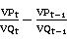. If significant correlation exists, volume can help us to adjust the forecast value/range.

Improvements

Range Forecast Based Trading
We only buy CLP and short sell HKE when rt-0.5*stdev(rt) >0 and do the opposite direction when rt+0.5*stdev(rt)<0. Below is the back-testing result (details are in forecast.xls).
Total return | 54.1%
Total + return | 63.5%
Total - return | -9.4%
$return on $1 loss | 6.76
number of trades | 25
profitable trades | 20
hit ratio | 80%
Although the total return declined from 162% to 54.1%, but we only take 25 trades to get this achievement while 162% takes us 328 trades. Hit ratio increased from 58% to 80% and $return on $1 loss increased from 1.88 to 6.76, which is amazing.

STDev Prediction with GARCH Model
Using MA(1) model, the stdev(rt) doesn’t change at all. But we all know that’s not true in the real market. The volatility should change over time. If we can model and forecast the volatility, we may get more information about the accuracy of our forecast of the stock ratio.
Fortunately, GARCH model may be a good choice for modeling the volatility. So we try AR-GARCH model on the log return of the price ratio. In SAS, we tried three different GARCH, which are GARCH(1,0), GARCH(0,1) and GARCH(1,1). Below are the results.
AR(1) GARCH(1,0) on log_ratio_return
The AUTOREG Procedure
Dependent Variable log_ratio_return
Ordinary Least Squares Estimates
SSE 0.18110246 DFE 329
MSE 0.0005505 Root MSE 0.02346
SBC -1535.2705 AIC -1539.0696
Regress R-Square 0.0000 Total R-Square 0.0000
Durbin-Watson 2.4963
Standard Approx
Variable DF Estimate Error t Value Pr > |t|
Intercept 1 0.000420 0.001292 0.33 0.7453
Estimates of Autocorrelations
Lag Covariance Correlation -1 9 8 7 6 5 4 3 2 1 0 1 2 3 4 5 6 7 8 9 1
0 0.000549 1.000000 | |********************|
1 -0.00014 -0.257032 | *****| |
Preliminary MSE 0.000513
Estimates of Autoregressive Parameters
Standard
Lag Coefficient Error t Value
1 0.257032 0.053361 4.82
Integrated GARCH Estimates
SSE 0.17000546 Observations 330
MSE 0.0005152 Uncond Var .
Log Likelihood 768.409069 Total R-Square 0.0613
SBC -1519.4209 AIC -1530.8181
Normality Test 774.0919 Pr > ChiSq <.0001
AR(1) GARCH(0,1) on log_ratio_return
The AUTOREG Procedure
Dependent Variable log_ratio_return
Ordinary Least Squares Estimates
SSE 0.18110246 DFE 329
MSE 0.0005505 Root MSE 0.02346
SBC -1535.2705 AIC -1539.0696
Regress R-Square 0.0000 Total R-Square 0.0000
Durbin-Watson 2.4963
Standard Approx
Variable DF Estimate Error t Value Pr > |t|
Intercept 1 0.000420 0.001292 0.33 0.7453
Estimates of Autocorrelations
Lag Covariance Correlation -1 9 8 7 6 5 4 3 2 1 0 1 2 3 4 5 6 7 8 9 1
0 0.000549 1.000000 | |********************|
1 -0.00014 -0.257032 | *****| |
Preliminary MSE 0.000513
Estimates of Autoregressive Parameters
Standard
Lag Coefficient Error t Value
1 0.257032 0.053361 4.82
Integrated GARCH Estimates
SSE 0.17000546 Observations 330
MSE 0.0005152 Uncond Var .
Log Likelihood 768.409069 Total R-Square 0.0613
SBC -1519.4209 AIC -1530.8181
Normality Test 774.0919 Pr > ChiSq <.0001
AR(1) GARCH(1,1) on log_ratio_return
The AUTOREG Procedure
Dependent Variable log_ratio_return
Ordinary Least Squares Estimates
SSE 0.18110246 DFE 329
MSE 0.0005505 Root MSE 0.02346
SBC -1535.2705 AIC -1539.0696
Regress R-Square 0.0000 Total R-Square 0.0000
Durbin-Watson 2.4963
Standard Approx
Variable DF Estimate Error t Value Pr > |t|
Intercept 1 0.000420 0.001292 0.33 0.7453
Estimates of Autocorrelations
Lag Covariance Correlation -1 9 8 7 6 5 4 3 2 1 0 1 2 3 4 5 6 7 8 9 1
0 0.000549 1.000000 | |********************|
1 -0.00014 -0.257032 | *****| |
Preliminary MSE 0.000513
Estimates of Autoregressive Parameters
Standard
Lag Coefficient Error t Value
1 0.257032 0.053361 4.82
Integrated GARCH Estimates
SSE 0.17009742 Observations 330
MSE 0.0005154 Uncond Var .
Log Likelihood 817.069312 Total R-Square 0.0608
SBC -1610.9423 AIC -1626.1386
Normality Test 121.5429 Pr > ChiSq <.0001
According to the AIC test, GARCH(1,1) is the best model to fit our data. Just like what we do to the MA(1) model, we apply the model back to the data and do a back-testing. (Details are in forecast_garch.xls)
If we use point forecast to make trade decision, as shown below, the result doesn’t improve at all.
Total return | 140.55%
Total + return | 336.17%
Total - return | -195.62%
$return on $1 loss | 1.72
number of trades | 328
profitable trades | 189
hit ratio | 58%
If we use range forecast (+/- 0.5*sd) to make trade decision, there will be only 1 trade, which could not be evaluated.
Total return | 5.25%
Total + return | 5.25%
Total – return | 0.00%
$return on $1 loss | invalid
number of trades | 1
profitable trades | 1
hit ratio | 100%
So the GARCH model can’t make improvement to our strategy. The unstable volatility forecasted by GARCH makes us lose opportunities to open good positions.

Volume Adjustment
In the beginning of the report, we have already tested the return-volume relationship for single stock. We now test the relationship between MA(1) model forecast residuals and the vol_ratio_change one period before. According to the SAS result, the correlation between them is almost zero, which means the volume change here doesn’t provide us any additional information on the forecast accuracy.
correlation between forecast residual and volume
The CORR Procedure
2 Variables: residual vol_ratio_change
Simple Statistics
Variable N Mean Std Dev Sum Minimum Maximum
residual 330 2.62582E-6 0.02258 0.0008665 -0.07441 0.11145
vol_ratio_change 331 -0.00251 0.51735 -0.83003 -2.26733 3.17816
Pearson Correlation Coefficients
Prob > |r| under H0: Rho=0
Number of Observations
vol_ratio_
residual change
residual 1.00000 -0.01369
0.8043
vol_ratio_change -0.01369 1.00000
0.8043

Conclusion and Future Work
In this project, we use time series analysis technique to examine two stocks for our pair trading strategy. The ARIMA analysis suggests that the price ratio is the appropriate figure of merit. And then we fit an MA(1) model.
Based on this model, using forecast value +/- 0.5 sd, the strategy works quite well.

Appendix
MAFS513.sas | SAS program
CLPHKEweekly.csv | Raw stock data
Resi_volume.csv | Data for testing correlation between return and volume ratio change
Forecast.xls | Back-testing for MA(1) model
Forecast_garch.xls | Back-testing for AR(1)-GARCH(1,1) model

