Risk Early Warning Indicators

Name Student ID
Hon Wai Cheong 99334042
Yu Chun Tung 08812095
Lai Chi Kwong 05816454

12th May, 2010

MAFS Quantitative Analysis of Financial Time Series

Department of Mathematics

The Hong Kong University of Science and Technology

Content

1 Background 3
2 Data Analysis 4
2.1 VIX index 4
2.2 MOVE index 5
2.3 TED spread 6
3 Modeling 7
3.1 ARMA-GARCH Model of VIX Index 7
3.2 ARMA-GARCH Model of MOVE Index 12
3.3 ARMA-GARCH Model of TED spread 21
4 Performance of the Risk Indicators 25
5 Conclusion 30
Appendix A - FARMA Model of VIX Index 31
Appendix B - VAR model of S&P and VIX Index 32
Appendix C – Source Data and SAS Program Codes 34

Background

The collapse of Lehman Brothers has slashed an unprecedented financial shock across the globe. It initiated a deactivating wave over all major markets. In the wake of this Tsunami, stock markets plunged, money markets dried up, some other banks were overwhelmed.

Since then, attitude towards financial risk management has changed dramatically in an international scale. Regulatory bodies have imposed stricter and stricter rules onto banks. Banks are also more willing to devote resource into the research and development of risk management systems.

However, there are still many technical difficulties concerning risk manager. One of them is the early detection of financial crisis. If the early signs of trouble can be detected, further losses can be contained.

On 4th May, 2010, “Soaring VIX Index May Signal More Trouble Ahead for Stocks” was headlined in CNBC. It is market wisdom to believe that VIX index is one of the early warning indicators for a downturn of a market.
Soaring VIX Index May Signal More Trouble Ahead for Stocks, CNBC, 4th May, 2010



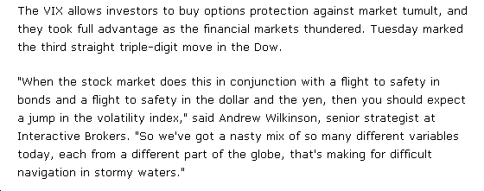

In this project, we try to model three commonly used financial risk indicators with time series techniques. These indicators include 1) the VIX index, 2) the MOVE index and 3) the TED spread.

First of all, the VIX index is a weighted blend of prices for a range of options on the S&P 500 index. In the market, it is often referred to as the fear index, it represents one measure of the market's expectation of volatility over the next 30 day period.

MOVE stands for Merrill Option Volatility Estimate. It is a yield curve weighted index of the normalized implied volatility on 1-month Treasury options. This index serves similar purpose with the VIX but it focus on Fixed-income market.

TED spread is the difference between 3-months USD LIBOR and the 3-months government notes. It measures the liquidity among the inter-bank money market.

Data Analysis
In this paper, we extracted the daily closing prices of VIX index, MOVE index and TED spread from 2nd January 1995 to 31st December 2009 from Bloomberg. There are 3914 observations in total. The TED spread is calculated based on 3M LIBOR minus the Yield of 3M US Treasury bill.

VIX index
In the market, the VIX index is called “fear index”. Practitioners believe that the index level represents the cost to purchase an insurance to protect against the downturn of the market. Generally, the VIX index level will be high during crises or volatile markets. We would consider the VIX index as a reflection of the fear of the equity investors.

Based on the graph above, it is observed that the VIX index would soar sharply during the financial crises in the last decades. Crises were nearby when there were sharp jumps in the index level and the index level would maintain in a high level, say over 25, which is the 3rd Quartile of the dataset, over a certain period.

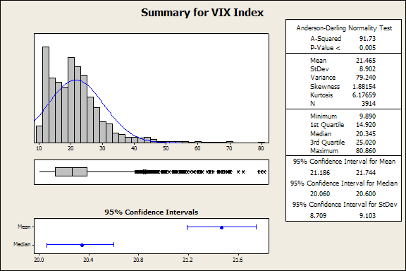

MOVE index
MOVE index is similar to VIX index. As it is a volatility of treasury option, we consider the MOVE index as a reflection of the fear of the fixed income investors.

Based on the graph above, similar to VIX index, it is observed that the MOVE index would soar sharply during the financial crises in the last decades. Crises were nearby when there were sharp jumps in the index level and the index level would maintain in a high level, say over 117, which is the 3rd Quartile of the dataset, over a certain period.

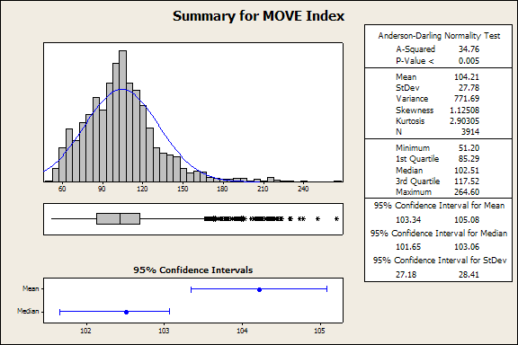

TED spread
The TED spread represents the average credit spread of financial institutions against US government yield. This figure reflects how financial institutions are eager to lend to each others. A high level represents the banking liquidity is dry.

Based on the graph above, similar to VIX index, it is observed that the TED spread would soar sharply during the financial crises in the last decades. Crises were nearby when there were sharp jumps in the spread level and the spread level would maintain in a high level, say over 0.6, which is the 3rd Quartile of the dataset, over a certain period.

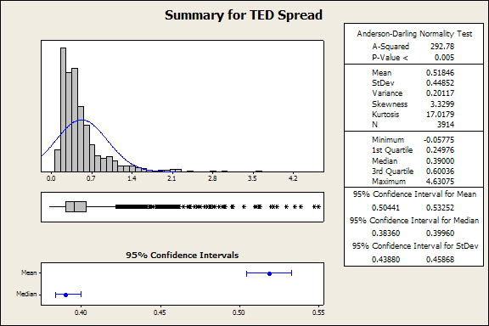

Modeling

ARMA-GARCH Model of VIX Index
The daily log return is calculated as r_{t} = log(VIX_{t}) – log(VIX_{t-1}) with the plot shown below. It is a stationary process with a cluster pattern and we will study it with the ARIMA analysis first.

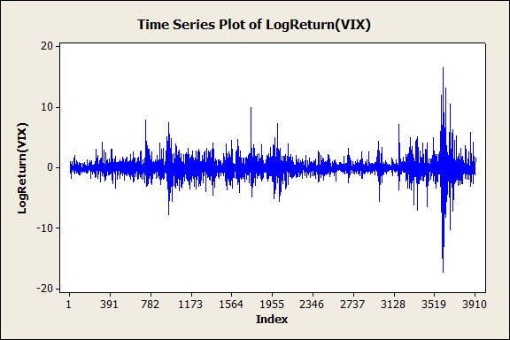

Autocorrelation Function: LogReturn(VIX)

Lag ACF T LBQ
1 -0.092406 -5.78 33.44
2 -0.117801 -7.31 87.79
3 -0.003279 -0.20 87.84
4 -0.072026 -4.41 108.17
5 0.038737 2.36 114.05
6 -0.038809 -2.36 119.96
7 -0.053609 -3.26 131.23
8 0.019738 1.20 132.76
9 -0.011597 -0.70 133.28
10 0.082778 5.01 160.18
11 -0.010308 -0.62 160.60
12 -0.056022 -3.37 172.92
13 0.016043 0.96 173.93
14 -0.000656 -0.04 173.93
15 0.032237 1.93 178.02
16 -0.013176 -0.79 178.70
17 0.003996 0.24 178.76
18 0.006208 0.37 178.91

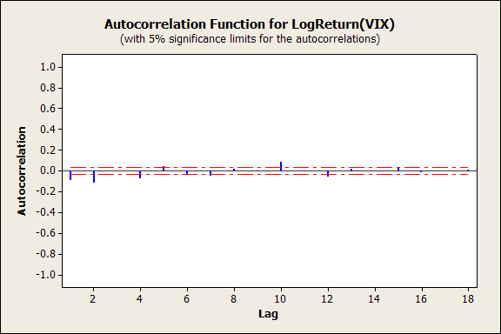

Partial Autocorrelation Function: LogReturn(VIX)

Lag PACF T
1 -0.092406 -5.78
2 -0.127428 -7.97
3 -0.028017 -1.75
4 -0.092677 -5.80
5 0.017886 1.12
6 -0.055861 -3.49
7 -0.061160 -3.83
8 -0.010916 -0.68
9 -0.024385 -1.53
10 0.072267 4.52
11 -0.005077 -0.32
12 -0.037347 -2.34
13 -0.000381 -0.02
14 -0.000858 -0.05
15 0.028777 1.80
16 -0.008474 -0.53
17 0.021917 1.37
18 0.000571 0.04

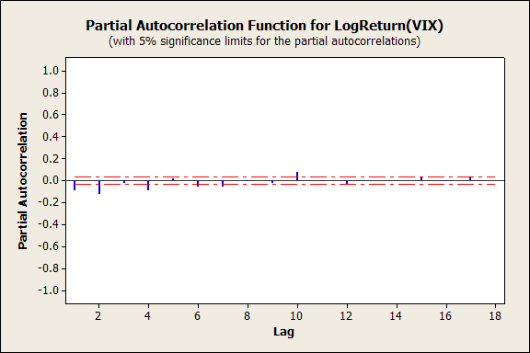

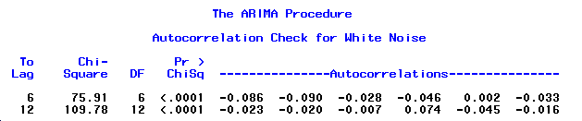

The Lijung-Box Q Statistics of the ρ₁₂ is 109.78 with p-value <0.0001. Therefore, we reject H0 and conclude that there is at least one ρ_{i}≠0 for 1<=i<=12. Therefore, there exists serial correlation relationship in the log return of VIX index.

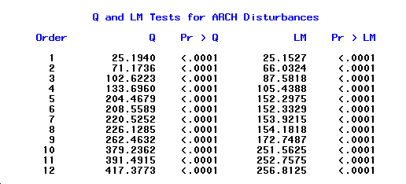
Based on the Q and LM tests, obviously, there exists ARCH effect in the log return of VIX index.

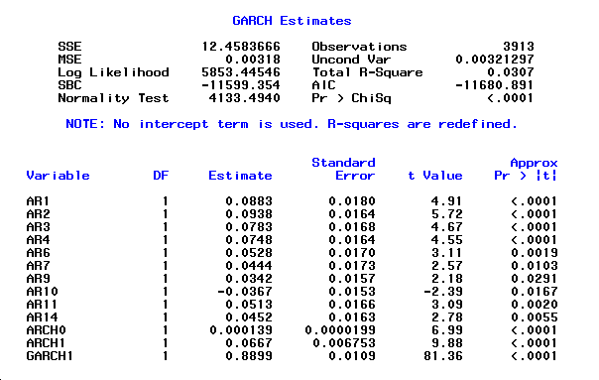

By fitting an AR(14)-GARCH(1,1) model, the formula is:

$$\begin{aligned}(1−0\text{.}\text{0883}B−0\text{.}\text{0938}B^{2}−0\text{.}\text{0783}B^{3}−0\text{.}\text{0748}B^{4}−0\text{.}\text{0528}B^{6} \\ −0\text{.}\text{0444}B^{7}−0\text{.}\text{0342}B^{9}+0\text{.}\text{0367}B^{\text{10}}−0\text{.}\text{0513}B^{\text{11}}−0\text{.}\text{0452}B^{\text{14}})r_{t}=a_{t} \\ \\ a_{t}=σ_{t}ε_{t} \\ σ_{{}_{t}}^{2}=0\text{.}\text{000139}+0\text{.}\text{0667}a_{t−1}^{2}+0\text{.}\text{8899}σ_{{}_{t−1}}^{2}\end{aligned}$$

Variable = ε_{t}
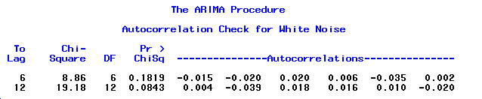

Variable = ε_{t}²
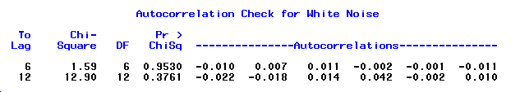

The Ljung-Box statistics of the residuals give Q(12) = 19.18 with p value 0.0843 and that of square of residuals give Q(12) = 12.90 with p value 0.3761. Consequently, the AR(14)-GARCH(1,1) model is adequate for the data at the 5% significance level.

The graph below is the in-sample forecasts of the last 100 observations:

In fact, it seems that there exists a long-memory characteristic in the time series. We can consider to use other models such as Fractional ARMA model (see Appendix A).
In addition, to investigate the relationship between the S&P and VIX index, we can fit these two indices into a Vector Autoregressive (VAR) model (see Appendix B).

ARMA-GARCH Model of MOVE Index
MOVE index is a yield curve weighted index of the normalized implied volatility on 1-month Treasury options. It is the weighted average of volatilities on the CT2, CT5, CT10, and CT30.

A plot of the log of the daily index of Merill Option Volatility Estimate (MOVE) for the period 2 Jan 1995 to 31 Dec 2009 is shown below.
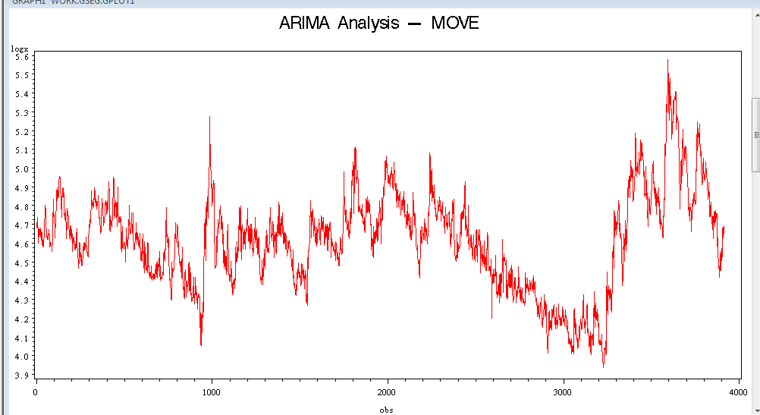

The daily log return is calculated as r_{t} = log(MOVEt) – log(MOVEt-1) with the plot shown below. It is a stationary process and we will study it with the ARIMA analysis.

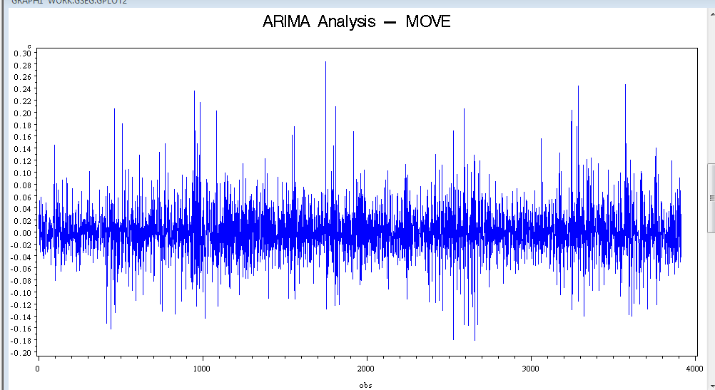

The ACF and PACF of the daily log return are shown below. Some of the correlations are larger than 2 standard deviations, so there is some evidence of serial correlation.

Based on the Ljung-Box statistics of the residuals show Q(6) = 86.49 and Q(12)=91.76, both with p value less than 0.05. So there is statistical evidence of serial correlation in the daily log returns at 5% significance level.

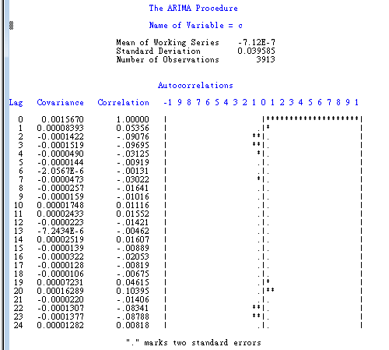

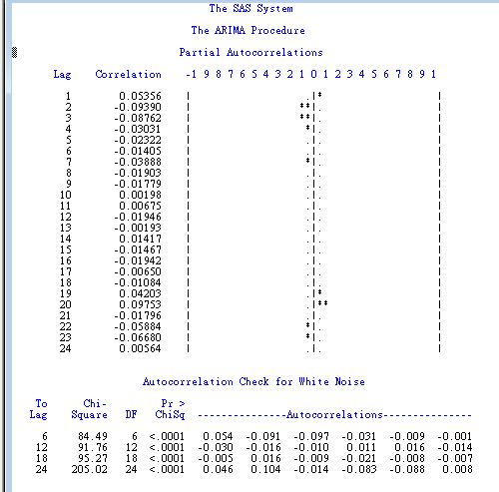

As shown in the Minimum Information Criterion Table below, the correlations may be explained by an ARMA(2,2) model.
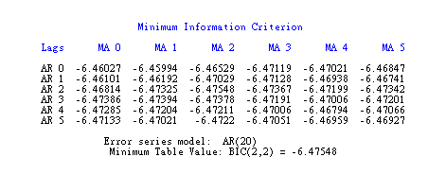
By fitting an ARMA(2,2) model, the residuals up to lag 18 are not statistically significant at 5% level.
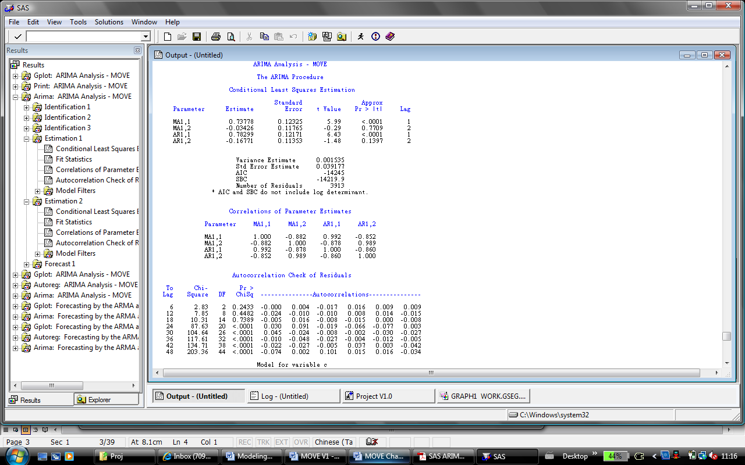

As shown in the table below, both the Q and LM tests detect ARCH effect in the daily log return (up to lag of order 12) at 5% significance level. So, it is appropriate to fit the daily log return with an AR-GARCH model. Initially, we test with an AR(3)-GARCH(1,1) model.

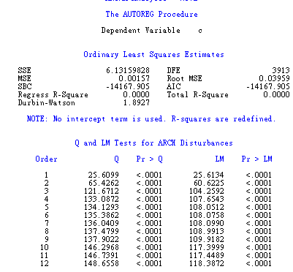

An AR(3) - GARCH(1,1) model (with the form shown below) is fitted for the daily log return of MOVE index using normal distribution for the innovations.
$\begin{aligned}(1−φ_{1}B−φ_{2}B^{2}−φ_{3}B^{3})r_{t}=a_{t} \\ a_{t}=σ_{t}ε_{t} \\ σ_{{}_{t}}^{2}=α_{0}+α_{1}a_{t−1}^{2}+β_{1}σ_{{}_{t−1}}^{2}\end{aligned}$
where r_{t} is the daily log return of MOVE index

All the parameters of AR(3)-GARCH(1,1) are statistically significant at 5% level.
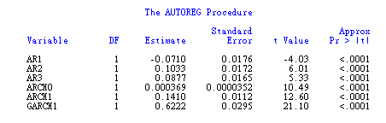
As shown in the checking of eta and eta2 below, it confirms that the model is adequate.

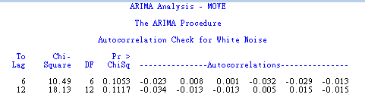
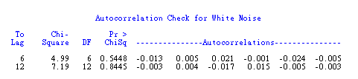
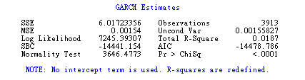

Thus, the fitted model AR(3)-GARCH(1,1) is adequate:
$$\begin{aligned}(1+0\text{.}\text{071}B−0\text{.}\text{1033}B^{2}−0\text{.}\text{0877}B^{3})r_{t}=a_{t} \\ a_{t}=σ_{t}ε_{t} \\ σ_{{}_{t}}^{2}=0\text{.}\text{000369}+0\text{.}\text{141}a_{t−1}^{2}+0\text{.}\text{622}σ_{{}_{t−1}}^{2}\end{aligned}$$

Is there any better model?

- Model AR(3)-GARCH(2,2)
First, we check a GARCH(2,2) model. As the parameters ARCH2 and GARCH2 are not statistically significant at 5% level, this model is not adopted. 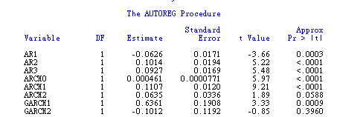

2. Model AR(3)-GARCH(2,1) and AR(3)-GARCH(1,2)
Both models are adequate but they are not as simple as GARCH(1,1). So they are not adopted. The output for AR(3)-GARCH(2,1) are shown below.
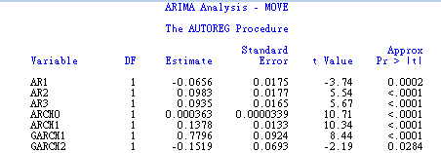

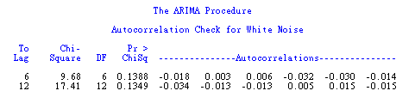

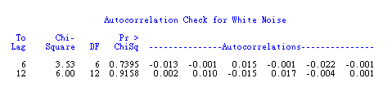

3. Model AR(3)-GARCH(0,1)
The model is adequate but the SBC is not as low as that of AR(3)-GARCH(1,1). So, this model is not adopted.
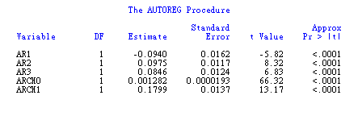

4. Model AR(3)-GARCH(1,1)-M
As the parameter Delta is not statistically significant at 5% level, this model is not adopted.
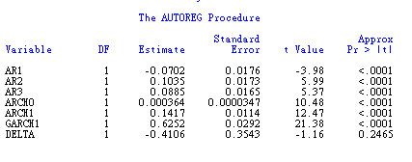
5. Model AR(3)-IGARCH(1,1)
The model is adequate but the SBC is not as low as that of AR(3)-GARCH(1,1). So, this model is not adopted.
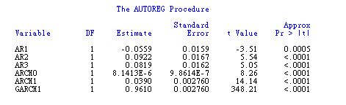
6. Model AR(3)-EGARCH(1,1)
As shown in the output for model checking, Model AR(3)-EGARCH(1,1) is also adequate.

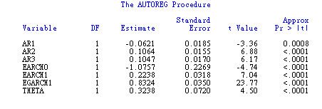
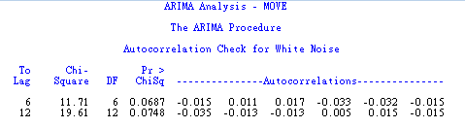
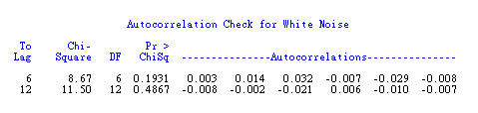
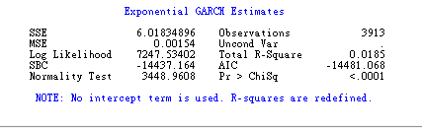

The fitted model is:
$$\begin{aligned}(1+0\text{.}\text{0621}B−0\text{.}\text{1064}B^{2}−0\text{.}\text{1047}B^{3})r_{t}=a_{t} \\ a_{t}=σ_{t}ε_{t} \\ \text{ln}(σ_{{}_{t}}^{2})=−1\text{.}\text{0757}+0\text{.}\text{2238}g(ε_{t−1})+0\text{.}\text{8324}\text{ln}(σ_{{}_{t−1}}^{2})\text{where} \\ g(ε_{t})=0\text{.}\text{3238}ε_{t}+\left|ε_{t}\right|−\sqrt{\frac{2}{π}}\end{aligned}$$
By comparing the SBC and AIC of EARCH(1,1) with GARCH(1,1), their values are very close. The sum of SBC and AIC is slightly better for GARCH(1,1) is lower than that of EGARCH(1,1), the model EGARCH(1,1) is not adopted.

 | SBC | AIC | Total  (SBC+AIC)
AR(3)-GARCH(1,1) | ★-14,441.2 | -14,478.8 | ★-28,920.0
AR(3)-EGARCH(1,1) | -14,437.2 | ★-14,481.1 | -28,918.3

Having said that, the EARCH(1,1) model provides us some insight in understanding the asymmetric effect between positive and negative log return.

As Theta is not equal zero at 5% statistical level, there is asymmetric effect between positive and negative log return.

When ε_{t} ≧0,
$\begin{aligned}g(ε_{t})=0\text{.}\text{3238}ε_{t}+\left|ε_{t}\right|−\sqrt{\frac{2}{π}}=1\text{.}\text{3238}ε_{t}−0\text{.}\text{7979} \\ \text{ln}(σ_{{}_{t}}^{2})=−1\text{.}\text{0757}+0\text{.}\text{2238}(1\text{.}\text{3238}ε_{t−1}−0\text{.}\text{7979})+0\text{.}\text{8324}\text{ln}(σ_{{}_{t−1}}^{2}) \\ \text{ln}(σ_{{}_{t}}^{2})=−1\text{.}\text{25427}+0\text{.}\text{8324}\text{ln}(σ_{{}_{t−1}}^{2})+0\text{.}\text{2963}ε_{t−1} \\ σ_{{}_{t}}^{2}=e^{−1\text{.}\text{25427}}σ_{{}_{t−1}}^{2(0\text{.}\text{8324})}e^{0\text{.}\text{2963}ε_{t−1}}\end{aligned}$
Whenε_{t} < 0,
$\begin{aligned}g(ε_{t})=0\text{.}\text{3238}ε_{t}+\left|ε_{t}\right|−\sqrt{\frac{2}{π}}=1\text{.}\text{3238}ε_{t}−0\text{.}\text{7979}=−0\text{.}\text{6762}ε_{t}−0\text{.}\text{7979} \\ \text{ln}(σ_{{}_{t}}^{2})=−1\text{.}\text{0757}+0\text{.}\text{2238}(−0\text{.}\text{6762}ε_{t−1}−0\text{.}\text{7979})+0\text{.}\text{8324}\text{ln}(σ_{{}_{t−1}}^{2}) \\ \text{ln}(σ_{{}_{t}}^{2})=−1\text{.}\text{25427}+0\text{.}\text{8324}\text{ln}(σ_{{}_{t−1}}^{2})−0\text{.}\text{1513}ε_{t−1} \\ σ_{{}_{t}}^{2}=e^{−1\text{.}\text{25427}}σ_{{}_{t−1}}^{2(0\text{.}\text{8324})}e^{−0\text{.}\text{1513}ε_{t−1}}\end{aligned}$

For example, for a standardized shock with magnitude 2 (i.e. 2 standard deviations), we have,
$$\frac{σ_{{}_{t}}^{2}(ε_{t−1}=2)}{σ_{{}_{t}}^{2}(ε_{t−1}=−2)}=\frac{e^{−1\text{.}\text{25427}}σ_{{}_{t−1}}^{2(0\text{.}\text{8324})}e^{0\text{.}\text{2963}(2)}}{e^{−1\text{.}\text{25427}}σ_{{}_{t−1}}^{2(0\text{.}\text{8324})}e^{−0\text{.}\text{1513}(−2)}}=\frac{e^{0\text{.}\text{2963}(2)}}{e^{−0\text{.}\text{1513}(−2)}}=e^{0\text{.}\text{29}}=1\text{.}\text{3364}$$

That is, the impact of a positive shock on the MOVE index of size 2 standard deviation is about 34% higher than that of a negative shock of the same size. It demonstrates the asymmetric feature of EGARCH model. It is consistent with the plot of the difference in log return of MOVE index. The magnitude of upward movement is higher than that of downward movement.

Thus, we adopt the AR(3)-GARCH(1,1) model.
$$\begin{aligned}(1+0\text{.}\text{071}B−0\text{.}\text{1033}B^{2}−0\text{.}\text{0877}B^{3})r_{t}=a_{t} \\ a_{t}=σ_{t}ε_{t} \\ σ_{{}_{t}}^{2}=0\text{.}\text{000369}+0\text{.}\text{141}a_{t−1}^{2}+0\text{.}\text{622}σ_{{}_{t−1}}^{2}\end{aligned}$$

Model | SBC | AIC | Total  (SBC+AIC)
AR(3)-GARCH(1,1) | ★-14,441.2 | -14,478.8 | ★-28,920.0
AR(3)-GARCH(1,2) | -14,437.1 | -14,481.0 | -28,918.1
AR(3)-GARCH(2,1) | -14,436.6 | -14,480.5 | -28,917.1
AR(3)-GARCH(2,2) | -14,429.1 | -14,479.3 | -28,908.4
AR(3)-GARCH(0,1) | -14,323.1 | -14,354.4 | -28,677.5
AR(3)-GARCH(1,1)-M | -14,434.2 | -14,478.1 | -28,912.3
AR(3)-IGARCH(1,1) | -14,354.7 | -14,386.1 | -28740.8
AR(3)-EGARCH(1,1) | -14,437.2 | ★-14,481.1 | -28,918.3

ARMA-GARCH Model of TED spread

The TED spread is actually measuring the funding cost for banks. During crisis, investor’s confidence towards banks drop and so the funding cost surge.
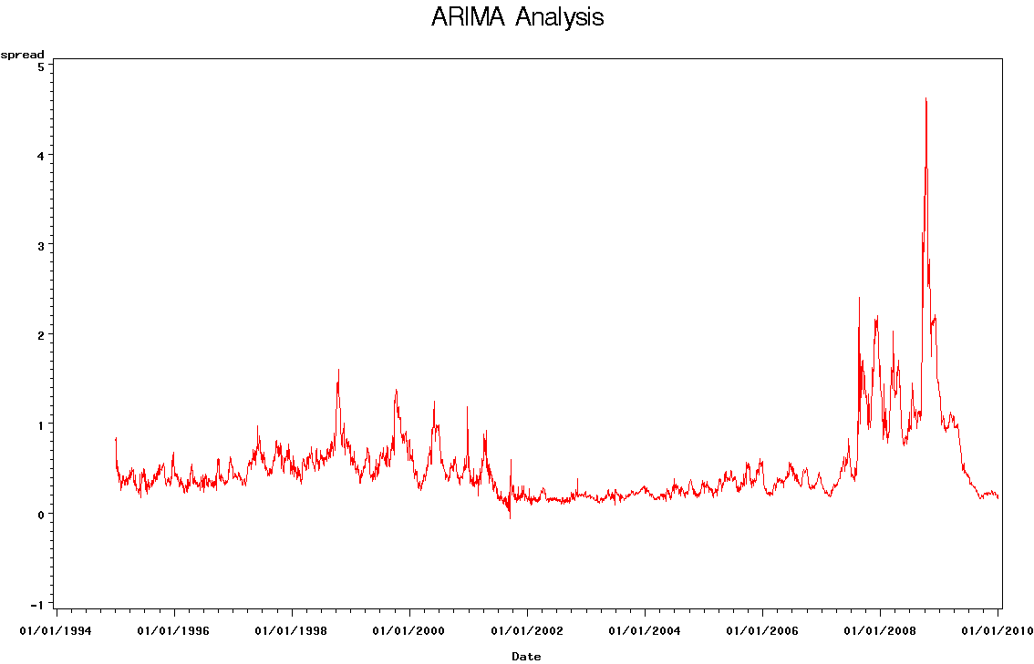
From the ARIMA analysis, it seems that the series is not from ordinary ARMA model. Therefore, we turn to investigate the daily log difference of the series. Since there would be either positive or negative spread value in the series, we transform the data as the following before taking difference.

log_spread = log(100-TED)

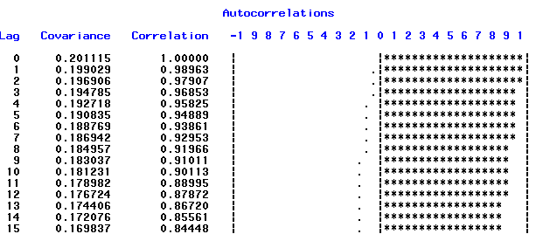

log(100-TED):
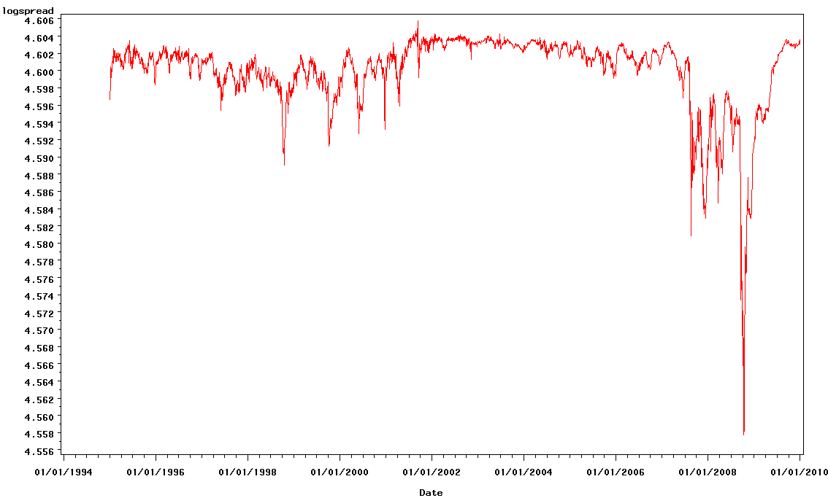
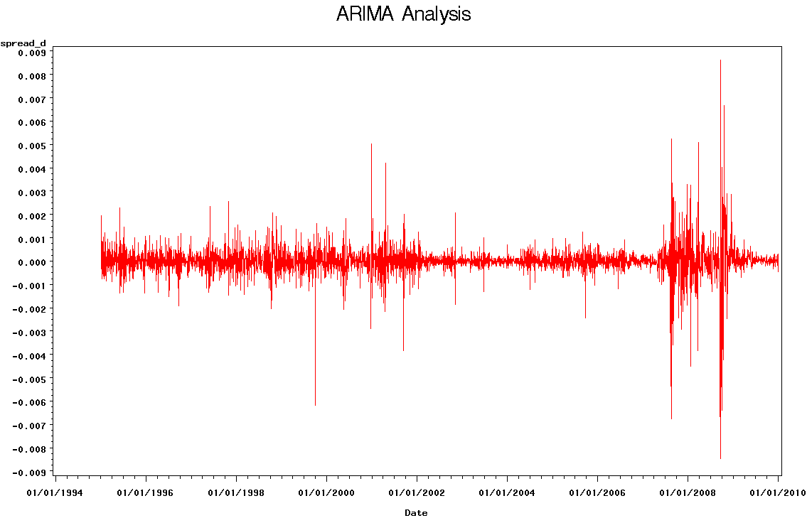
From the ACF and PACF analysis of the daily difference, there seems to be no short-term serial correlation between daily data but there exists correlation at some special time intervals. This may be related to the rollover activities in the money market. This is also evidenced from the ACF analysis of the LIBOR data.

ACF of TED spread daily log-difference:
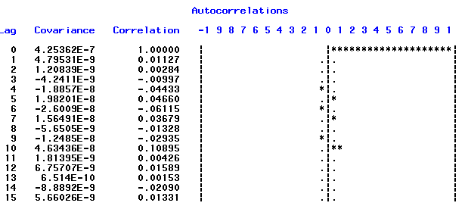

ACF of LIBOR daily log-difference:
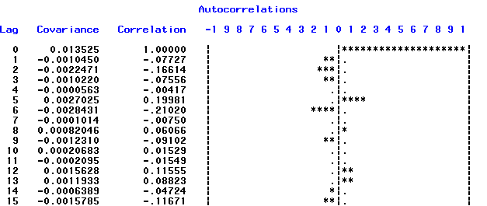

ACF of 3-months Treasury bill yield daily log difference:
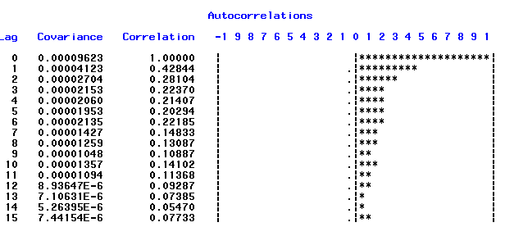

Furthermore, significant ARCH effect can be observed from the Q-test and LM-test results.
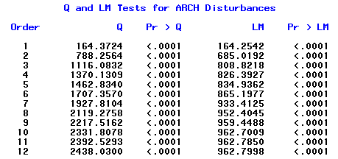

The above results suggest an ARMA-GARCH model is appropriate to model the series. After a number of trial-and-errors, the fitted model is as the following. All the parameters are also found to be significant and the model is adequate at 5% confident level.

$$\begin{aligned}(1+0\text{.}\text{061}B^{5}−0\text{.}\text{0497}B^{6}+0\text{.}\text{0804}B^{\text{10}}+0\text{.}\text{0413}B^{\text{30}})r_{t}=a_{t} \\ a_{t}=σ_{t}ε_{t} \\ \text{ln}(σ_{{}_{t}}^{2})=−\text{15}\text{.}\text{1801}+\sum_{t=1}^{\text{14}}{α_{t}g(ε_{t−1})}+0\text{.}\text{8324}\text{ln}(σ_{{}_{t−1}}^{2})\text{where} \\ g(ε_{t})=−0\text{.}\text{0574}ε_{t}+\left|ε_{t}\right|−\sqrt{\frac{2}{π}}\end{aligned}$$
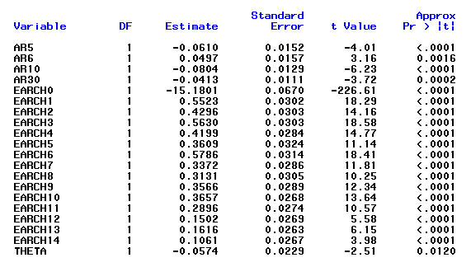
Checking for eta:
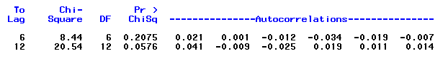
Checking for eta2:
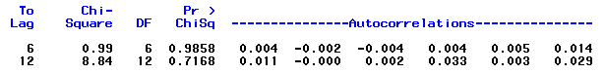

The graph below is the in-sample forecasts of the last 100 observations:

Summary of the proposed models

Index | Model
VIX Index | AR(14)-GARCH(1,1)
MOVE Index | AR(3)-GARCH(1,1)
TED Spread | AR(30)-EGARCH(14,0)

Performance of the Risk Indicators

We would try to evaluate the performance of our indictors by observing how they react to historical events.

We would define the indicator to be switched on when all the three observed indices cross-over the upper bound of our 95% confident prediction interval. Across the 3914 observation day there are totally 11 occurrences of risk signals, they are summarized in the following table. We found that within 2 months of the warning signal, there exists high probability of major crisis event happening.

Signal Date | Relevant Crisis | Event Date | Predicting Power
27/08/1998 | Failure of LTCM | 23/09/1998 | One month ahead
20/12/2000 | Nil
27/02/2007 | HSBC Profit Warning | 5/03/2007 | 5 days ahead
26/07/2007 | Chapter 11 for American Home Mortgage | 6/08/2007 | 10 days ahead
09/08/2007 | Bank run of Northern Rock | 13/09/2007 | 1 month ahead
01/11/2007 | Citibank and Merrill Lynch reported huge credit loss | Mid Jan 2008 | 1 - 2 months ahead
07/11/2007 | Citibank and Merrill Lynch reported huge credit loss | Mid Jan 2008 | 1 - 2 months ahead
11/12/2007 | Citibank and Merrill Lynch reported huge credit loss | Mid Jan 2008 | 1 - 2 months ahead
22/01/2008 | Collapse of Bear Sterns | 17/03/2008 | 1.5 months ahead
15/09/2008 | Collapse of Lehman Brothers | 15/09/2008 | On collapse day
29/09/2008 | Collapse of Lehman Brothers | 15/09/2008 | Lag

From our observation above, the indicators can predict major crises with 73% accuracy.

 | Number of alerts occurred | %
Correct Prediction | 8 | 73%
Incorrect Prediction | 1 | 9%
Lagged Indication | 2 | 18%
Total | 11 | 100%

The warning during the Dot-com bubble (20/12/2000) was classified as a false alarm as there is no notable events happened on a particular day but the collapse occurred as a prolonged depression.

The mechanism can be illustrated as follows:

Collapse of LTCM

Collapse of Bear Stearns

Conclusion
In this paper, we proposed a crisis prediction mechanism with an impressively high successful rate of 73%. This approach incorporates three major financial risk indices, which cover the dynamics of the equity market, fixed income market and interbank money market. The mechanism can be a helpful tool for policymakers, risk managers, traders, bank’s senior management to evaluate market conditions and take early action before distress events. In the future, this framework can be enhanced by (1) including additional market indices/factors and (2) capturing the interaction dynamics in different markets by fitting into more sophisticated models such as VAR-GARCH model.

Appendix A - FARMA Model of VIX Index
We can consider fitting the log return of VIX index into Fractional ARMA models. Two possible models are:

By fitting a fractional ARMA(10, -0.016,0) model,
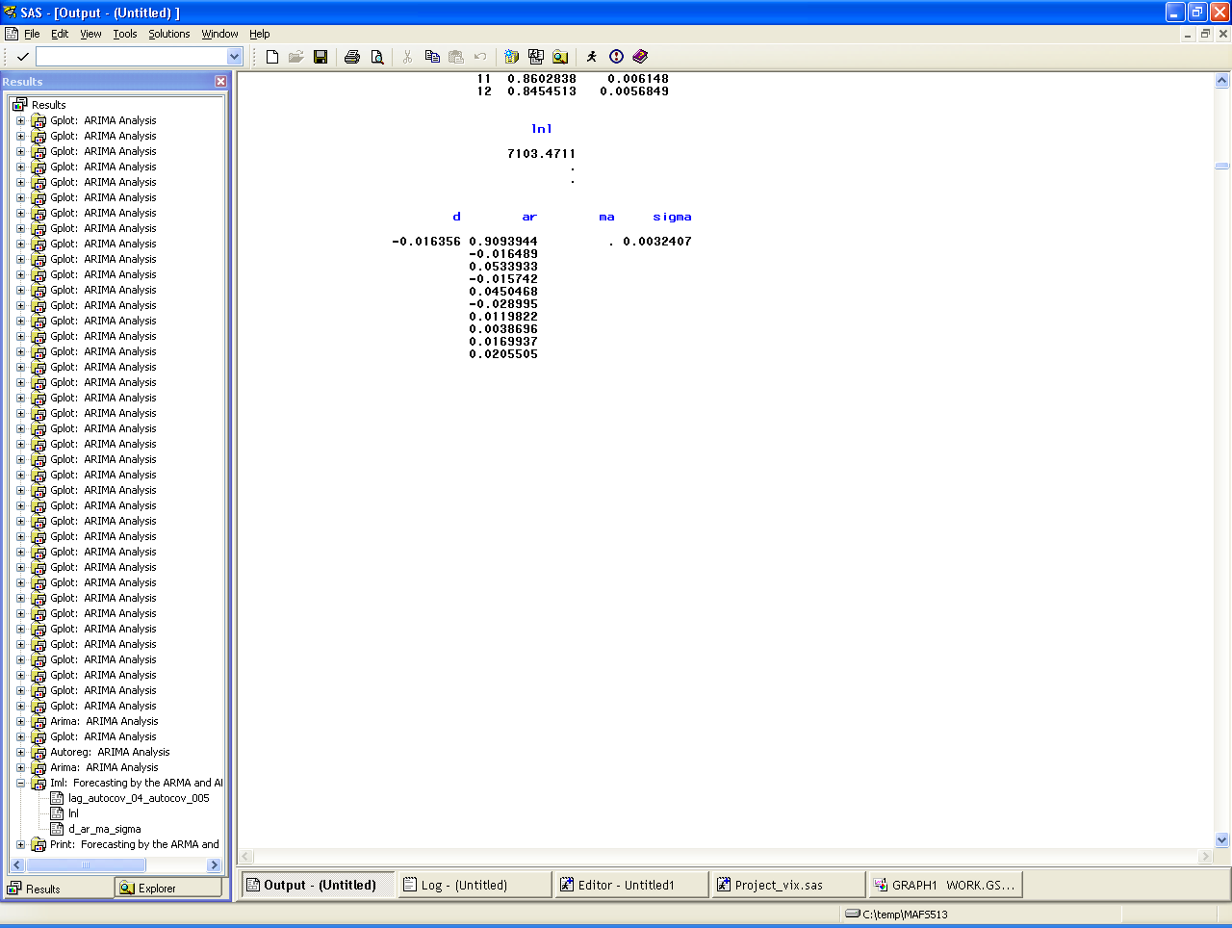
By fitting a fractional ARMA(0, 0.930,10) model,

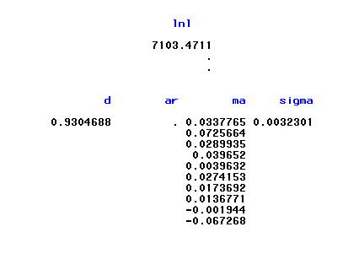

Appendix B - VAR model of S&P and VIX Index

To investigate the relationship between the S&P and VIX index, we conduct a cross correlation analysis of these two indices. The daily log return of S&P and VIX index are calculated as SP_{t} = log(SP_{t}) – log(SP_{t-1}) and x_{t} = log(VIX_{t}) – log(VIX_{t-1}). The cross-correlation matrixes show there is significant cross-correlation at lag 1, 2, 4, 6, 7, 8, 10 and 11.

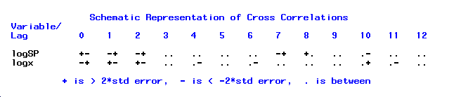

A VAR(11) may be a possible model to be considered.

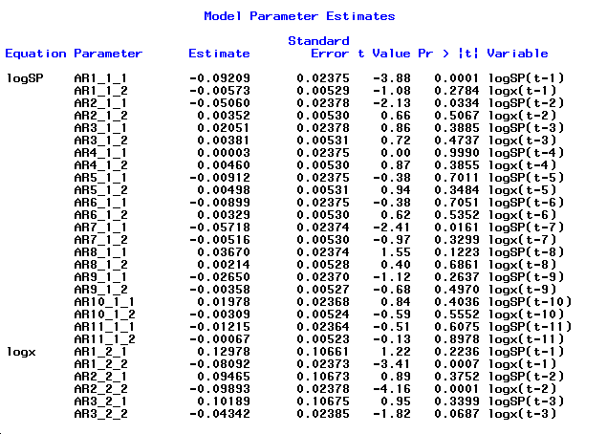
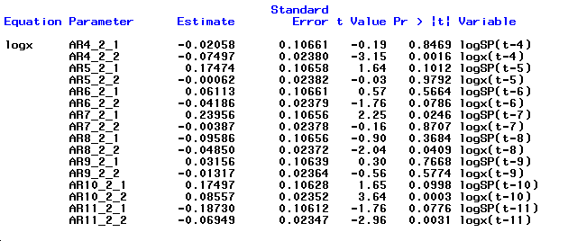

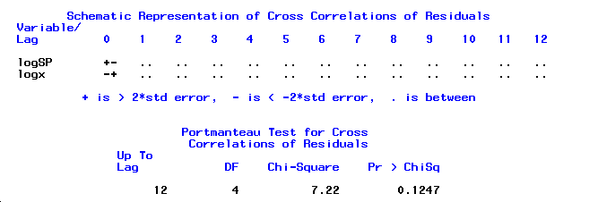

The Portmanteau Test of the residuals give Q(12) = 7.22 with p value 0.1247. Consequently, the VAR(11) model is adequate for the data at the 5% significance level.

There are other possible models such as VAR-GARCH. However, there are too many parameters and we do not consider them here.

Appendix C – Source Data and SAS Program Codes

Source Data:

SAS Code:
To run the SAS Program, please save the source data to C:\temp\

Modeling of VIX Index:
Modeling of MOVE Index:
Modeling of TED Spread:

Andrew Sheng, From Asian to Global Financial Crisis, 2009

