Hong Kong University of Science of Technology

MAFS511-Qnautitative Analysis of Financial Time Series

Project Report

What affects our house price?
- A time series study of the Centa-City Index (CCI) of Hong Kong property prices

By

Name Student ID
CHAN, Kam Ming 03741459
LEUNG, Chiu Ming 08812174
NG, Kwok Leung 97209360
TANG, Hon Ping 08819079
WONG, Chiu Wah 98267943

May 2011

Instructor: Dr. Ling Shiqing

TABLE OF CONTENTS

TABLE OF CONTENTS | 02
LIST OF APPENDICES | 03
1. INTRODUCTION | 04
2. AGGREGATE BALANCE | 06
3. INTEREST RATES | 08
4. UNITED STATES DOLLAR INDEX | 13
5. HANG SENG INDEX | 17
6. CONSUMER PRICE INDEX | 20
7. GROSS DEOMESTIC PRODUCT | 22
8. COMBINED MODELS | 25
9. CONCLUSION AND FORECAST | 34
10. APPENDICES | 36

LIST of APPEDNICES

Appendix A | SAS output of CCI | 36
Appendix B | SAS output of aggregate balance | 41
Appendix C | SAS output of interest rates | 46
Appendix D | SAS output of DXY | 49
Appendix E | SAS output of HSI | 53
Appendix F | SAS Output of CPI | 59
Appendix G | SAS Output of GDP | 63
Appendix H | SAS output of the combined models | 66

- Introduction

International experience suggests that movements in housing prices have important implications for macroeconomic and financial stability. In Hong Kong, the relationship between the housing market and the wider economy is of particular significance for a number of reasons.

Firstly, the property market plays an important role in the Hong Kong economy. Housing is the most important form of saving for many households. In the banking sector, about half of domestic credit currently comprises mortgage loans for the purchase of private residential properties and loans for building and construction and property development. Changes in housing prices and rents influence consumer price inflation (CPI).

Moreover, under the Currency Board arrangements, interest rates in Hong Kong are largely determined by those in the United States and the risk premium that is required by investors for holding Hong Kong dollar (HKD) assets.

The purpose of this project is to investigate the relationship between housing prices and various well known financial and economic factors. The factors are listed as follows:

Housing Price
- | Centa-City Index (CCI)
Financial Factors
- | Monthly Liquidity (Aggregate Balance)
- | Interest Rates (Prime Rate and HIBOR)
- | Currency (DXY)
- | Stock Market (HSI)
Economic Factors
- | Inflation (CPI)
- | Economic Activities (GDP)

Methodology

1. Multivariate Vector Autoregressive Models (VAR) are used in the present study.

2. Study Period: From 1994-01 to 2011-02 (Monthly data)

Centa-City Index (CCI)

Investors and potential homebuyers are in need of indicators to study the current movement of property price in Hong Kong. The creation of the “Centa-City Index” aims to provide such information to the public as a source of reference on trends in Hong Kong’s property markets.

The CCI is a monthly index based on all transaction records as registered with the Land Registry to reflect property price movements in previous months. The following formula is used to calculate the CCI:

Centa-City Index (CCI) for a month | = | Total market value of the  constituent estates in the month | x | CCI for the  previous month
Centa-City Index (CCI) for a month | = | Total market value of constituent estates in the previous month | x | CCI for the  previous month

* The Property Price Index comprises a number of constituent estates.
* The market value of a constituent estate is the product of the total saleable area and the adjusted unit price.
* July 1997 is used as the base period of the index. The index in the base period equals 100.

- AGGREGATE BALANCE

The Aggregate Balance represents the level of interbank liquidity, and is a part of Monetary Base. In Hong Kong, this refers to the sum of the balances in the clearing accounts maintained by the banks with the HKMA for settling interbank payments and payments between banks and the HKMA.

Under the Linked Exchange Rate System, the Hong Kong Monetary Authority (HKMA) commits to buy US dollar at the exchange rate of HK$7.8 when funds flow into Hong Kong pushes up the demand and hence the price of Hong Kong dollar. So when there is inflow of funds, the aggregate balance will increase, hence the monetary base. That will mean higher liquidity in the interbank market, thus lower interest rates. On the contrary, if there is an outflow of fund which pushed down the price of Hong Kong dollar, HKMA will buy Hong Kong dollar and sell US dollar, thus the aggregate balance and monetary base will shrink. As liquidity is squeeze, interest rates would rise. In this section, Multivariate vector autoregressive models (VAR) is used to study the relationship between Aggregate Balance and CCI.
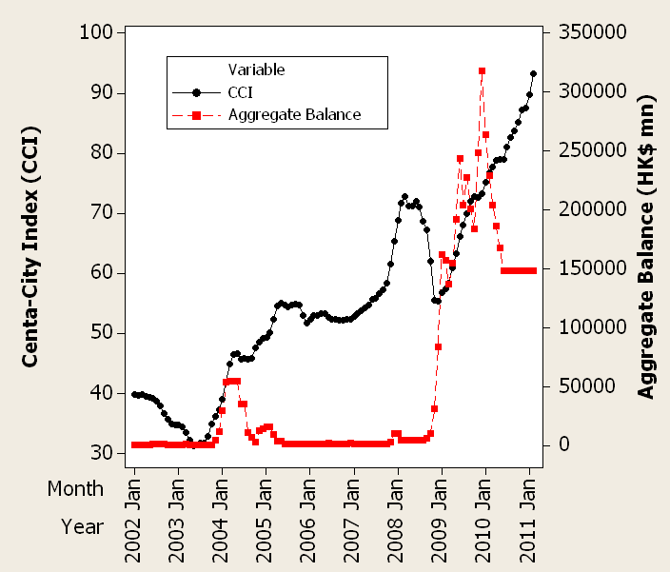

Figure 2.1 Housing Price (CCI) and Aggregate Balance

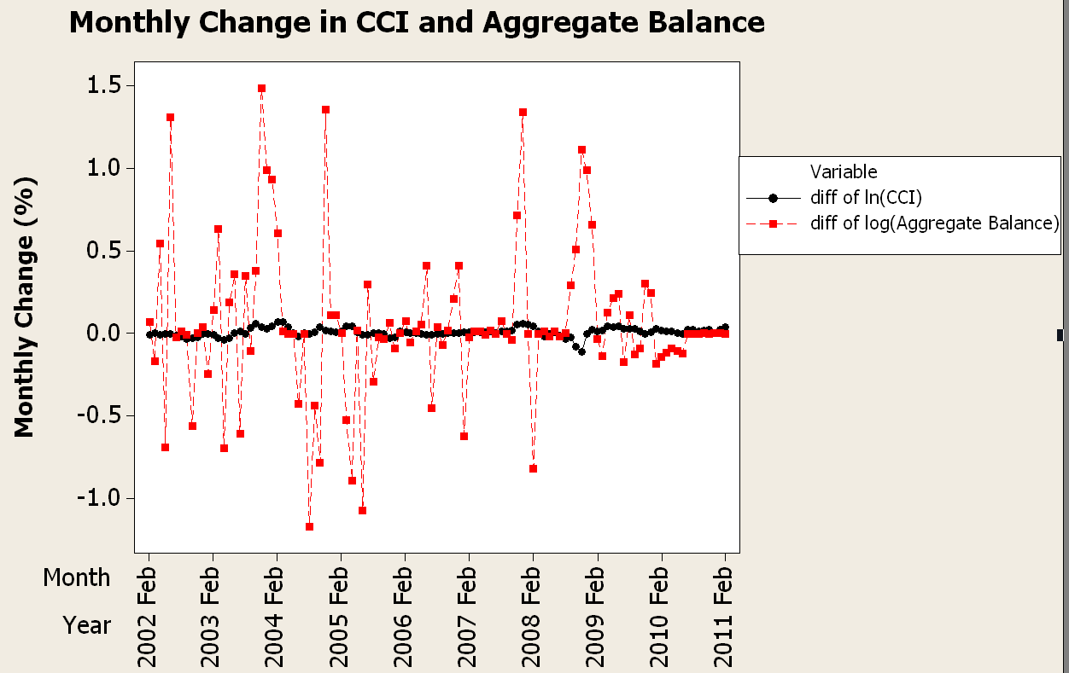
Figure 2.2 Monthly Changes in CCI and Aggregate Balance

The monthly data for CCI and Aggregate Balance are shown in Figure 2.1 and both series are not stationary. In order to remove the trend component from both series, we apply natural logarithmic transformation on the raw data and then the first difference of the log-data for individual series is used for modeling. Figure 2.2 indicates that both series become stationary after proper data transformation.

Dickey-Fuller Unit Root Test is conducted to confirm two transformed series are stationary and the results are listed in Table 2.1. The second column of Table 2.1 specifies three types of models, namely Zero Mean, Single Mean, and Trend. The third column (Rho) and the fifth column (Tau) are the test statistics for the unit root tests. The remaining columns (column 2 and column 6) are the p-values for corresponding models. As all the p-values are less then 0.05, in other words, both series are stationary (no drift and trend component) at the significant level of 5%.

Table 2.1 Result of Dickey-Fuller Unit Root Tests
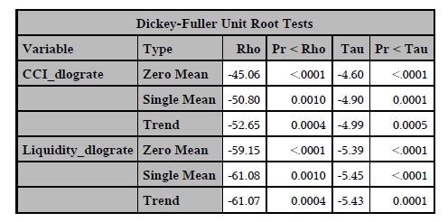

$Δ\text{ln}\left(\text{CCI}\right)$ and $Δ\text{ln}\left(\text{Aggregate} \text{Balance}\right)$ are fitted with VAR(p) models with different lags. VAR(1) is presented here (the others are listed in Appendix B):

$Δ\text{ln}\left({\text{CCI}}_{t}\right)=0\text{.}\text{74296}Δ\text{ln}\left({\text{CCI}}_{t−1}\right)+0\text{.}\text{007}Δ\text{ln}\left(\text{Aggreagte} {\text{Balance}}_{t−1}\right)+a_{1t}$ …(1)
$Δ\text{ln}\left(\text{Aggregate} {\text{Balance}}_{t}\right)=0\text{.}\text{31136}Δ\text{ln}\left({\text{CCI}}_{t−1}\right)+0\text{.}\text{18374}Δ\text{ln}\left(\text{Aggreagte} {\text{Balance}}_{t−1}\right)+a_{2t}$…(2)

Table 2.2 Result of VAR(1) model for $Δ\text{ln}\left(\text{CCI}\right)$ and $Δ\text{ln}\left(\text{Aggregate} \text{Balance}\right)$
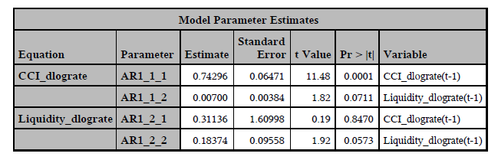

Since the p-values for both coefficients in Equation (1) are less than 0.1, and the results confirm that the coefficients are significant at the level of 10%. Moreover, the results show there is significant relationship between $Δ\text{ln}\left(\text{CCI}\right)$ and $Δ\text{ln}\left(\text{Aggregate} \text{Balance}\right)$. However, the impact of the Aggregate Balance on the Housing Price is relatively mild (as the coefficient is quite small: 0.007).

- INTEREST RATES

It is generally believed that interest rate is correlated with housing price and which reflects the borrowing cost and investment return. Most of the housing purchases are financed by mortgages. Therefore, mortgage rate is one of the significant costs of buying a house and which might be one of the determinants of the housing price.

Basically, 2 different mortgage plans are commonly available in Hong Kong. They are HIBOR rate plan and traditional prime rate plan.

HIBOR refers to Hong Kong Interbank Offer Rate. Normally, the bank strategy is to borrow short and lend long to capture the positive interest rate spread. The bank could borrow short term funding from their customer through traditional deposit or borrow the short term funding in the interbank market. HIBOR reflects the short term funding cost between different banks. HIBOR reflects the demand and supply of the funding in the interbank market and hence it is more responsive and volatile than the prime rate and is the best gauge of the market liquidity. It is a major source of funding for a smaller bank which has smaller deposit base compared to large banks.

The most liquid tenor of HIBOR quoted in Hong Kong market are Overnight, 1W, 2W, 1M, 2M, 3M and up to 12M.

Prime rate or prime lending rate indicate the rate of interest at which banks lent to favored customers, i.e., those with high credibility. Due to the mortgage loans are backed up by the real estate, it mitigate the bank’s risk undertaken, Henceforth, the banks could charge prime rate minus certain spread as the mortgage rate. Fixed rate mortgages are not common in Hong Kong although it is popular in US.

Prime rate and HIBOR plans have the similar market shares in Hong Kong. For HIBOR plan, most of the banks offer 1M HIBOR or 3M HIBOR as the reference rates, other tenors are not commonly available. For prime rate, different bank set their own different rate. However, due to the market competitive forces, the rates difference would be relatively small, it is normally up to 50bps as seen in the market. HSBC is the largest bank in the mortgage market, we therefore choose its prime rate in the study.

Model Checking: Difference of 1M HIBOR (Unit Root Test)

We first take the first difference on the 1M, 3M HIBOR and HSBC prime rate in the following analysis.

In Dickey-Fuller tests (Table 3.1), the second column specifies three types of models, which are zero mean, single mean, or trend. The third column (Rho) and the fifth column (Tau) are the test statistics for unit root testing. Other columns are their p-values. Both series do not have unit root.
Table 3.1 Result of Dickey-Fuller Unit Root Tests

In the Table 3.2 parameter estimates, first difference on 1M HIBOR is not significantly related to the housing index.
Table 3.2 Result of VAR(1) model for Δlog(CCI) and first difference on 1M HIBOR

Model Checking: Difference of 3M HIBOR (Unit Root Test)

The dickey-Fuller (Table 3.3) unit root tests show difference of 3M HIBOR do not have unit root.
Table 3.3 Result of Dickey-Fuller Unit Root Tests

In the Table 3.4 parameter estimates, first difference on 3M HIBOR is not significantly related to the housing index.
Table 3.4 Result of VAR(1) model for Δlog(CCI) and first difference on 3M HIBOR

Model Checking: Difference of HSBC prime rate (Unit Root Test)

The dickey-Fuller unit root tests (Table 3.5) show difference of HSBC prime rate do not have unit root.

Table 3.5 Result of Dickey-Fuller Unit Root Tests

In the Table 3.6 parameter estimates, interest rate is not significantly related to the housing index.
Table 3.6 Result of VAR(1) model for Δlog(CCI) and difference on Prime Rate
Interesting Findings on the relationship between interest rate and housing price

Our empirical findings against many common beliefs that the interest rates are not the significant factors in determining the housing price.

Our arguments is that the Interest rates reflect only the borrowing costs of the mortgagee. In reality, the home buyers can be grouped into real users or the investors.

The real users are more driven by their own needs, rather than the economic return. On the contrary, the investors are more concern on the appreciation of the house price which in turns depends on the economic environment.

Therefore, the borrowing costs may just be a tiny factor in their consideration.

- US Dollar Index (DXY)

The US Dollar Index (USDX) is an index (or measure) of the value of the United States dollar relative to a basket of foreign currencies. It is a weighted geometric mean of the dollar's value compared only with

Euro (EUR), 58.6% weight
Japanese Yen (JPY) 12.6% weight
Pound sterling (GBP), 11.9% weight
Canadian dollar (CAD), 9.1% weight
Swedish krona (SEK), 4.2% weight and
Swiss franc (CHF) 3.6% weight

USDX goes up when the US dollar gains "strength" (value) when compared to other currencies.

USDX started in March 1973, soon after the dismantling of the Bretton Woods system. At its start, the value of the US Dollar Index was 100.000. It has since traded as high as 148.1244 in February 1985, and as low as 70.698 on March 16, 2008, the lowest since its inception in 1973 (Figure 4.1).

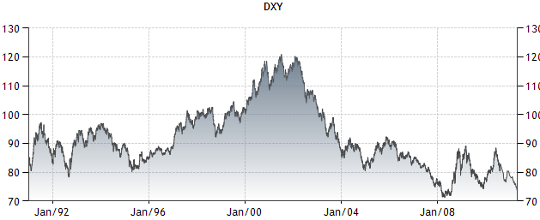
Figure 4.1 US Dollar Index from 1990 up to 2011

The Reason of Choosing US Dollar Index

As a response to the Black Saturday crisis in 1983, the linked exchange rate system was adopted in Hong Kong on October 17, 1983 at an internal fixed rate of HKD 7.80 = USD 1. So analyzing the US Dollar Index may also act as the proxy of power of HK Dollar in effecting the change in the property price.

Data Preparation

As similar we are taking log value different as the rate of change of the data. We apply to both CCI and US Dollar Index. We test the unit root from the Dicky-Fuller Test and shows that no indications of unit Root (Table 4.2 and Table 4.3)

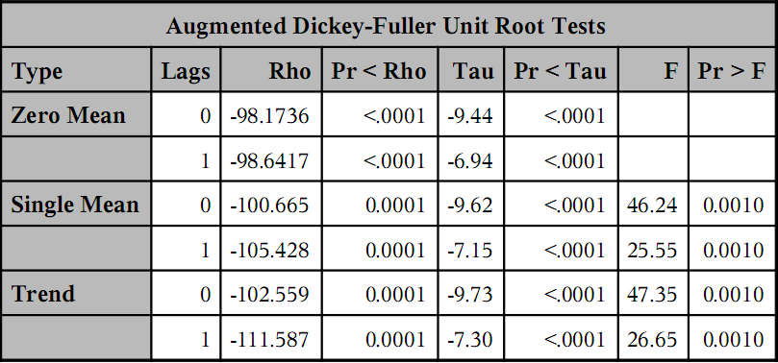
Table 4.2 Result of Dickey-Fuller Unit Root Tests on Δlog(Dollar Index)

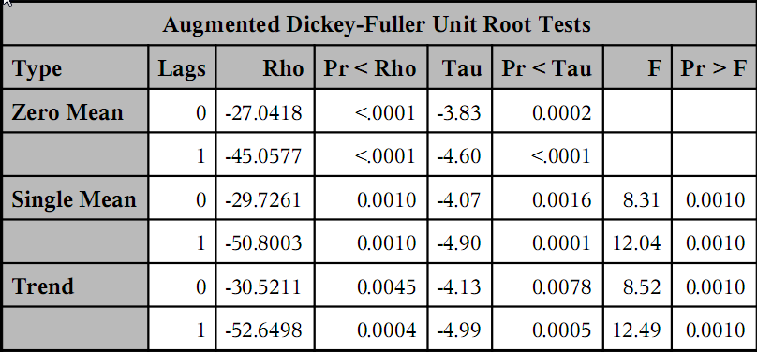
Table 4.3 Result of Dickey-Fuller Unit Root Tests on Δlog(CCI)

From Table 4.4 Representation checking of the Partial Cross Correlations Graph, we see that it may be possible for VAR(1), VAR(3) and VAR(4) at all.

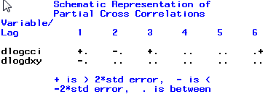
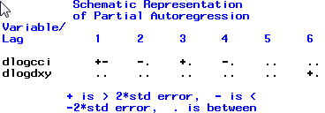
Table 4.4 Representation checking of the Partial Autoregression and Cross Correlations Graph
Table 4.5, Table 4.6 and Table 4.7 are the Result of Δlog(CCI) and Δlog(Dollar Index) under VAR(1), VAR(3) and VAR(4).

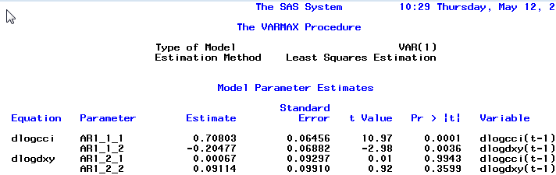
Table 4.5 Δlog(CCI) and Δlog(Dollar Index) under VAR(1)

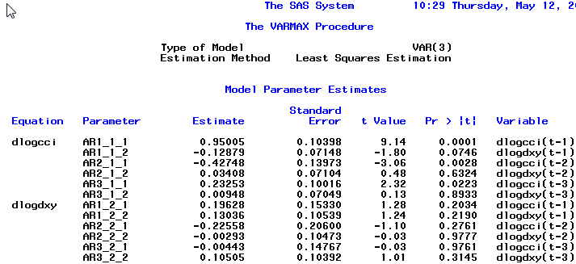
Table 4.6 Δlog(CCI) and Δlog(Dollar Index) under VAR(3)

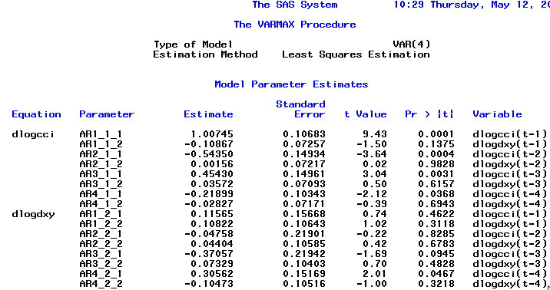
Table 4.7 Δlog(CCI) and Δlog(Dollar Index) under VAR(4)

Analysis

From these 3 results we see one common thing that P-value related to Δlog(Dollar Index) are highly insignificant. So we have doubt that whether Δlog(Dollar Index) really affecting Δlog(CCI) at all. So we apply a Granger-Causality test on the variables of interest.
The GROUP1=(VARIABLES) GROUP2=(VARIABLES) option enables you to specify the variables to be tested. The null hypothesis of the Granger-Causality test is that GROUP1 is influenced by itself, and not by GROUP2. If the test of hypothesis fails to reject the null, the variables in the GROUP1 may be considered as independent variables.

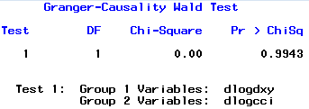
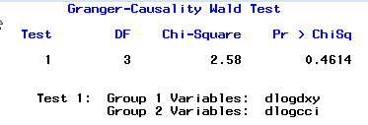
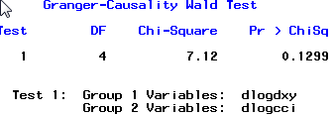
Table 4.8 Granger-Causality test for testing if Δlog(Dollar Index) is independent variable under VAR(1), VAR(3) and VAR(4).

Table 4.8 is the test results from the VAR(1) VAR(3) and VAR(4) that fail to reject the null hypothesis. So means that Δlog(Dollar Index) considered as independent variables.

Implication and Possible Reasons behind

- Dollar Value depreciation causes property price rise in economic theory. But this is not the case since the demand is sharply rise in property as the investment products due to hot money flow from China
- Also from point 1, change of building attitude of Property corporations in which concentrate in building luxury properties but not for affordable housing.

- Hang Seng Index

The Hang Seng Index (HSI) is a freefloat-adjusted market capitalization-weighted stock market index in Hong Kong. It is the main indicator of the overall stock market performance in Hong Kong. These 45 constituent companies represent about 60% of capitalization of the Hong Kong Stock Exchange.

The current Hang Seng Index is calculated from this formula:
Descriptions on parameters:
P(t)：Current Price at Day t
P(t-1)：Closing Price at Day (t-1)
IS：Issued Shares (Only H-share portion is taken into calculation in case of H-share constituents.)
FAF：Freefloat-adjusted Factor, which is between 0 and 1, adjusted quarterly
CF：Cap Factor, which is between 0 and 1, adjusted quarterly

In this section, Multivariate vector autoregressive models (VAR) is used to study the relationship between and HSI and CCI.

Figure 5.1 CCI vs HSI

Figure 5.1 show the trend of HSI and CCI. We normalized the graph by setting July 1997 as reference date for both HSI and CCI. The figure shows that both indexes have similar trend and direction. However, HSI is more volatile. From the graph, it looks like there should have some positive correlation between HSI and CCI.

Figure 5.2 CCI return vs HSI return

We study again on the return of both indexes. Figure 5.2 show that the log return of HSI is more violate than CCI. It seems that log returns of indexes are stationary, which is required for our model.

Figure 5.3 Dickey-Fuller Unit Root Tests
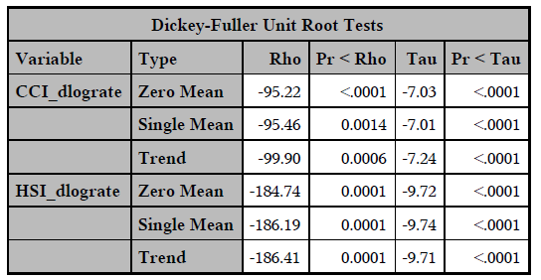

Dickey-Fuller Unit Root Test is conducted to confirm the log return of CCI and HSI series are stationary and the results are listed in Figure 5.3. The second column of Figure 5.3 specifies three types of models, namely Zero Mean, Single Mean, and Trend. The third column (Rho) and the fifth column (Tau) are the test statistics for the unit root tests. The remaining columns (column 2 and column 6) are the p-values for corresponding models. As all the p-values are less then 0.05, in other words, the series are stationary (no drift and trend component) at the significant level of 5%.

Figure 5.4 VAR(1) model for log return of CCI and HSI
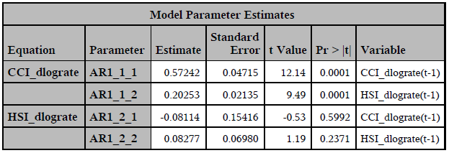

We tried different parameters in VAR model to fit our log return of CCI and HSI. We tried VAR(1), VAR(2), VAR(3), VAR(4), VAR(6), VAR(12) models and found that VAR(1) is the best one. VAR(1) shows that there is significant relationship between log return of CCI and HSI.

The VAR(1) model for CCI and HSI:
$Δ\text{ln}\left({\text{CCI}}_{t}\right)=0\text{.}\text{57242}Δ\text{ln}\left({\text{CCI}}_{t−1}\right)+0\text{.}\text{20253}Δ\text{ln}\left({\text{HSI}}_{t−1}\right)+a_{1t}$ …(1)

Since the p-values for both coefficients in Equation (1) are less than 0.05, and the results confirm that the coefficients are significant at the level of 5%. The result shows that HSI is significant factors in determining the housing price. Increase in HSI will tend to have increase in property price.

- CONSUMER PRICE INDEX

Consumer price index (CPI) measures the changes over time in the price level of consumer goods and services generally purchased by households. The year-on-year rate of change in the CPI is widely used as an indicator of the inflation. In this project, the monthly % changes of seasonally adjusted CPI (ΔCPI) of Hong Kong are used. The data is obtained from Hong Kong Census and Statistics Department and Figure 6.1 shows the data comparing with CCI changes.

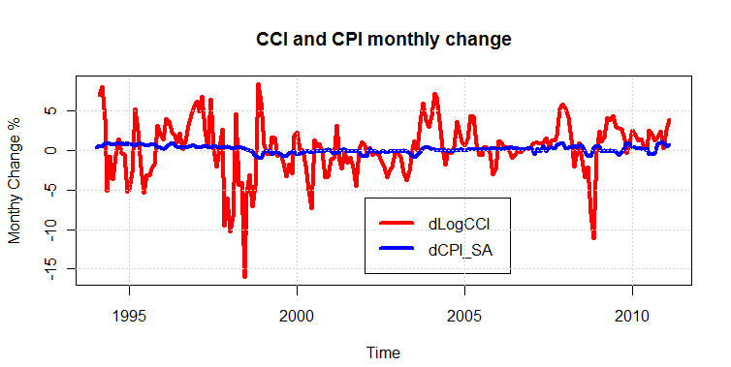
Figure 6.1 CCI and CPI monthly change

The Augment Dickey-Fuller test was done on ΔCPI. The result (Table 6.1) shows that ΔCPI does not contain any unit root, no drift and trend term.

Table 6.1 Augment Dickey-Fuller test of ΔCPI

Value of test-statistic is: -4.9906 8.3724 12.557
Critical values for test statistics:
1% 5% 10%
tau3 -3.99 -3.43 -3.13
phi2 6.22 4.75 4.07
phi3 8.43 6.49 5.47

Δlog(CCI) and ΔCPI are fitted VAR(p) model with different lags. VAR(4) and VAR(10) are tried and the detail results are listed in Appendix F. They do not show any significant relationship between them. The result of VAR(4) model is as follows:

Δlog(CCI_{t}) = 0.5776 Δlog(CCI_{t-1}) + a1_{t}

ΔCPI_{t} = 0.8514 ΔCPI_{t-1} - 0.4986 ΔCPI_{t-3} + 0.4938 ΔCPI_{t-4} + a2_{t}

The VAR(4) model has AIC value -19.16120. VAR(10) model gives similar results with less favorable AIC value. It is found that Δlog(CCI_{t}) did not contain any lagged term from ΔCPI. The VAR(4) model is checked with Grange’s causality test and the test result is shown in Table 6.2. Since the p-value of the test is not small, the null hypothesis is accepted and ΔCPI alone does not cause Δlog(CCI).

The result is counter-intuition because inflation rate is always thought to be the critical factor of the property price. It seems the relationship is not so straightforward. More investigations was made the combined models discussed in section 8.

Table 6.2 Granger’s causality of VAR(4) model

H0: dCPI_SA do not Granger-cause dCCI
data: VAR object CCI.CPI.var4
F-Test = 0.831, df1 = 4, df2 = 382, p-value = 0.506

- GROSS DEOMESTIC PRODUCT

Gross Domestics Product (GDP) is a measure of the total value of production of all resident producing units of a country or territory in a specified period, before deducting allowance for consumption of fixed capital. In here, the quarterly changes (%) of seasonally adjusted GDP (ΔGDP) are used. The data is from 1994-Q1 to 2010-Q4 and is obtained from Hong Kong Census and Statistics Department. The GDP quarterly changes are compared with CCI changes are shown in Figure 7.1.

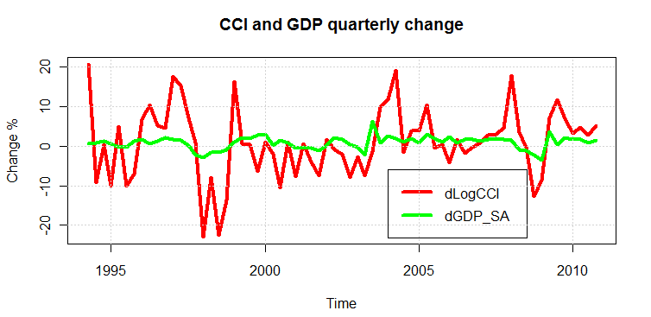
Figure 7.1 CCI and GDP quarterly changes

The Augment Dickey-Fuller test was done on ΔGDP. The result (Table 7.1) shows that ΔGDP does not contain any unit root.

Table 7.1 Augment Dickey-Fuller test of ΔGDP

Value of test-statistic is: -2.8658

Critical values for test statistics:
1% 5% 10%
tau1 -2.6 -1.95 -1.61

Δlog(CCI) and ΔGDP are fitted VAR(p) models of different lags with significant level 5%. VAR(1) gives the best result and the test details results are listed in Appendix G. The result of VAR(1) model is as follows:

Δlog(CCI_{t}) = 0.5776 ΔGDP_{t-1} + a1_{t}
ΔGDP_{t} = 0.2708 ΔGDP_{t-1} + a2_{t}

It is found the Δlog(CCI) contains one-month-lagged term of ΔGDP. However, ΔGDP does not have any term from Δlog(CCI). Then, the model is verified by checking the model’s residuals. The residuals, their ACF and partial ACF are shown in Figure 7.2.

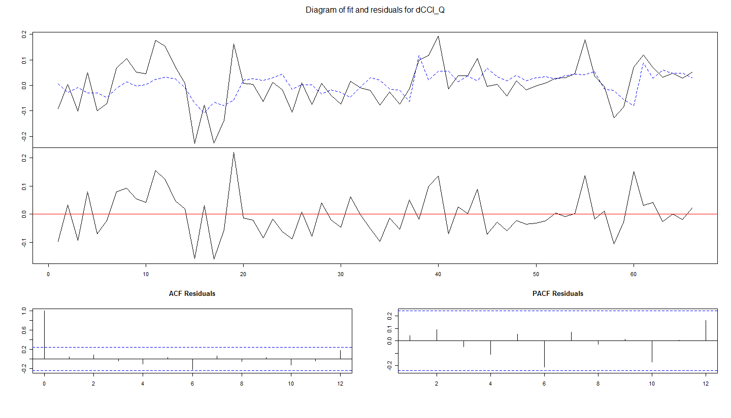
Figure 7.2 Checking the residuals of the VAR(1) model

The residuals are further checked with Portmanteau test with maximum lag=16. The result (Table 7.2) shows there is no autocorrelation among the residuals. Granger’s tests were done on Δlog(CCI) and ΔGDP. Their results showed that the ΔGDP was the Granger’s cause of the Δlog(CCI). However, the reverse is not true. These results confirmed that the VAR(1) model was appropriate.

Table 7.2 Portmanteau test and Granger’s causality test of VAR(1) model

Portmanteau Test Q16 (asymptotic)
Chi-squared = 46.9961, df = 60, p-value = 0.8894

H0: dGDP_SA do not Granger-cause dCCI_Q
data: VAR object CCI.GDP.var1
F-Test = 9.8328, df1 = 1, df2 = 124, p-value = 0.002141
Reject H0

H0: dCCI_Q do not Granger-cause dGDP_SA
data: VAR object CCI.GDP.var1
F-Test = 0.1508, df1 = 1, df2 = 124, p-value = 0.6984
Accept H0

The VAR(1) model showed that the housing price was affected by the GDP growth of one quarter before and housing price did not have any effect on the GDP growth. In order to understand GDP’s effect more, the impulse response of GDP on CCI was generated and shown in Figure 7.3. The figure showed that GDP growth might cause CCI change within eight quarters (two years)! Unfortunately, GDP only came as quarterly data, it cannot be employed in the combined models in the next section.
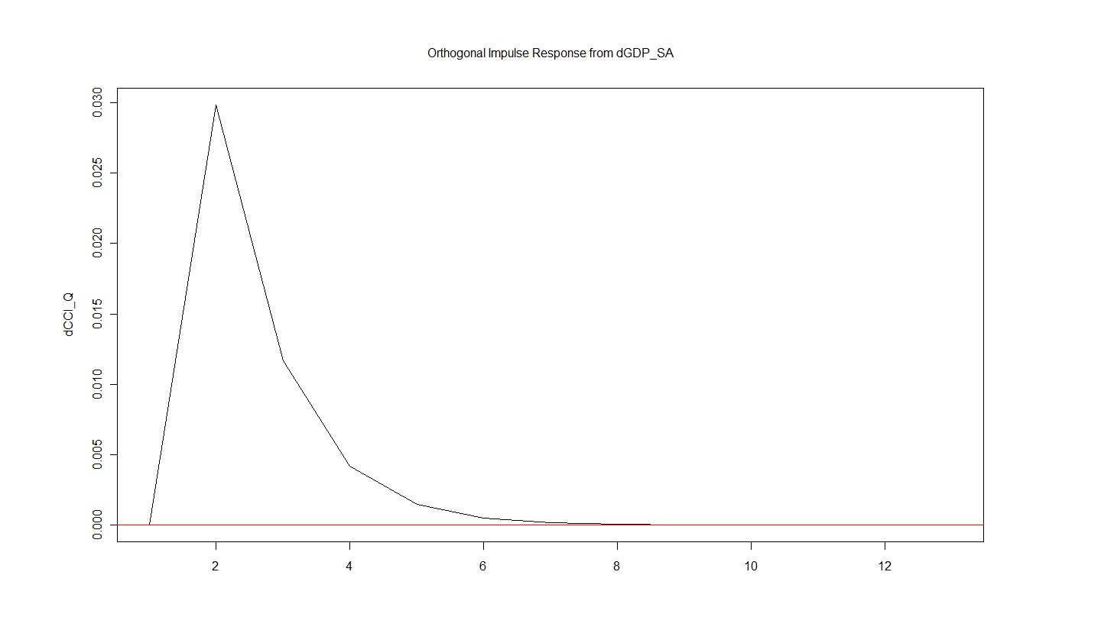
Figure 7.3 Impulse response of Δlog(CCI) for unit change of ΔGDP

- Combined factors

From the above results we see that Δlog(CCI) and one factor does not have much satisfaction result at all. So we suggest Δlog(CCI) with combined of factors. From the numerous testing we see below 3 possible models. We do not include GDP since it is not monthly data. The database is started from 2002 in which Monthly Liquidity started to published.

- Δlog(CCI) with Δlog(HSI), Δlog(Liquidity) and ΔCPI
- Δlog(CCI) with Δlog(HSI), ΔCPI and Δlog(Prime Rate)
- Δlog(CCI) with Δlog(HSI), Δlog(Liquidity), ΔCPI and Δlog(Prime Rate)

Δlog(CCI) with Δlog(HSI), Δlog(Liquidity) and ΔCPI

From below Table 8.1, it is suggest to be either like VAR(1) or VAR(2)
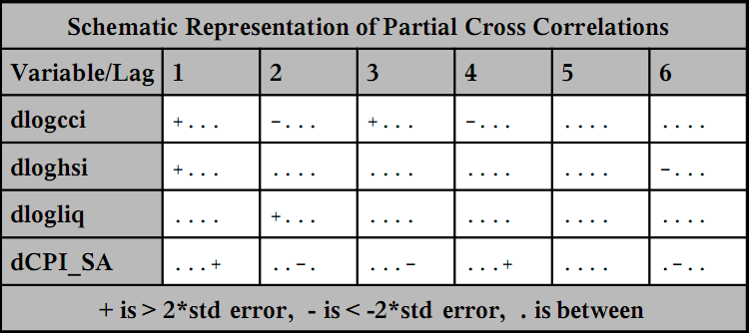
Table 8.1, partial Cross Correlations of Δlog(CCI) with Δlog(HSI), Δlog(Liquidity) and ΔCPI

Below are corresponding Information Criteria (Table 8.2) and the result of VAR(1) (Table 8.3)
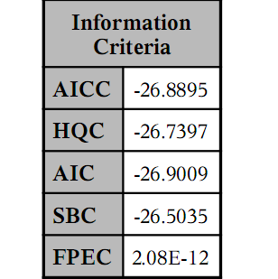
Table 8.2, Information Criteria of Δlog(CCI) with Δlog(HSI), Δlog(Liquidity) and ΔCPI under VAR(1) Model

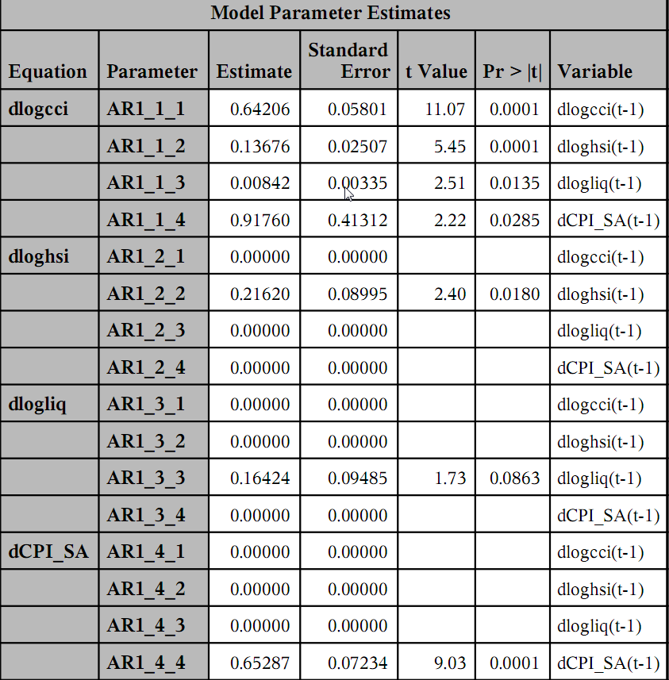
Table 8.3, Result of Δlog(CCI) with Δlog(HSI), Δlog(Liquidity) and ΔCPI under VAR(1) Model

Below are corresponding Information Criteria (Table 8.4) and the result of VAR(2) (Table 8.5)

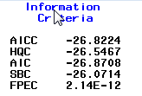
Table 8.4, Information Criteria of Δlog(CCI) with Δlog(HSI), Δlog(Liquidity) and ΔCPI under VAR(2) Model

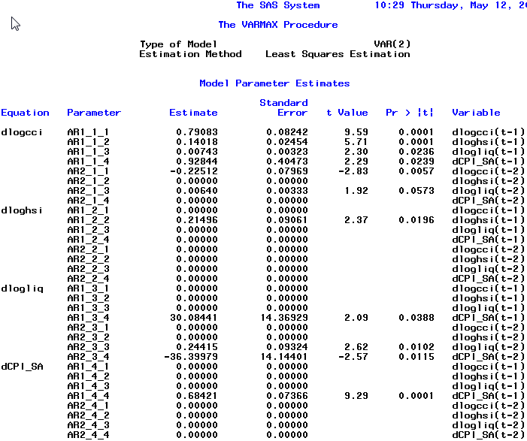
Table 8.5, Result of Δlog(CCI) with Δlog(HSI), Δlog(Liquidity) and ΔCPI under VAR(2) Model

Interpretation

From the two results we see that Δlog(HSI), Δlog(Liquidity) and ΔCPI itself related its 1st -lagged terms, except for Δlog(Liquidity) under VAR(2) model that affect by ΔCPI
Another idea is that ΔCPI itself may follow with it 1st -lagged term and 2nd -lagged term significantly but not for others.

Δlog(CCI) with Δlog(HSI), ΔCPI and Δlog(Prime Rate)

From below Tables 8.6, it is suggest to be VAR(1)

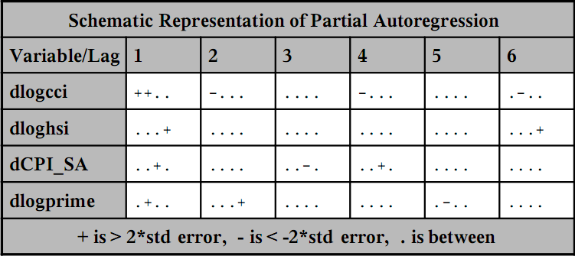
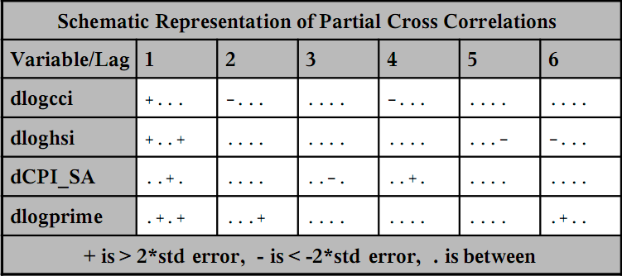

Table 8.6, partial Autoregression and partial Cross Correlations of Δ log(CCI) with Δlog(HSI), ΔCPI and Δlog(Prime Rate)

Below are corresponding Information Criteria (Table 8.7) and the result of VAR(1) (Table 8.8)
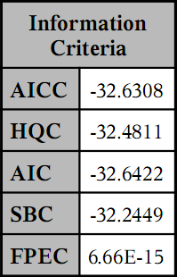
Table 8.7, Information Criteria of Δ log(CCI) with Δlog(HSI), ΔCPI and Δlog(Prime Rate) under VAR(1) Model
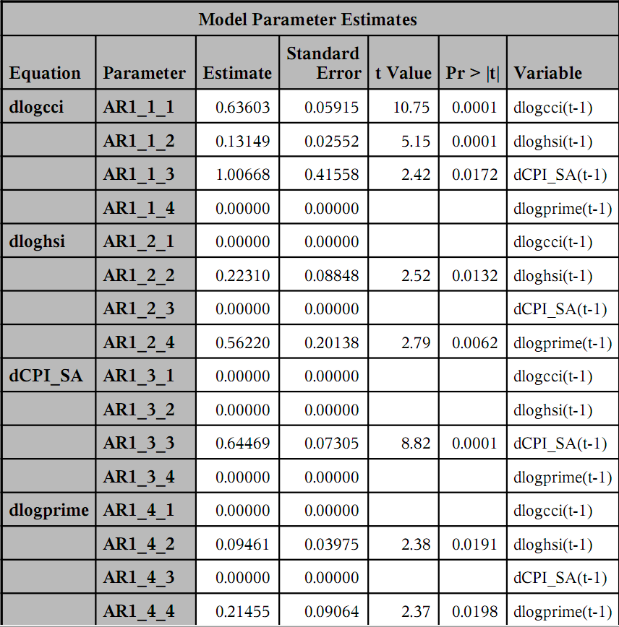
Table 8.8, Result of Δ log(CCI) with Δlog(HSI), ΔCPI and Δlog(Prime Rate) under VAR(1) Model

Interpretation
From the two results we see that Δlog(HSI), Δlog(Prime Rate) and ΔCPI itself related its 1st -lagged terms.
This model is more accurate by using AIC and BIC criteria.
Δlog(CCI) with Δlog(HSI), Δlog(Liquidity), ΔCPI and Δlog(Prime Rate)

From below Table 8.9, it is suggest to be VAR(1) or VAR(2) model

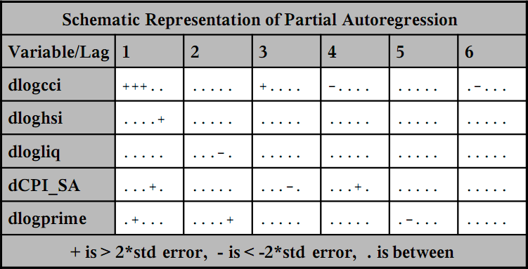
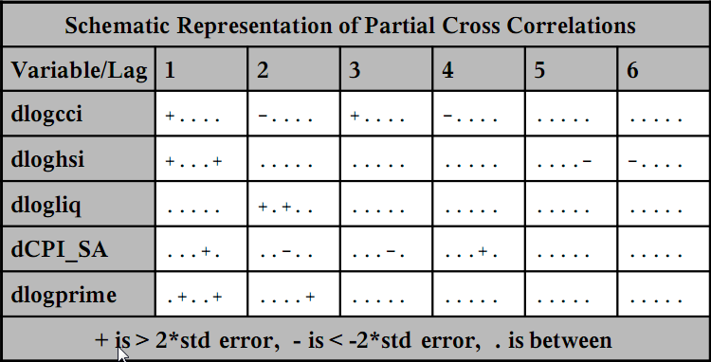
Table 8.9, partial Autoregression and partial Cross Correlations of Δ log(CCI) with Δlog(HSI), Δlog(Liquidity), ΔCPI and Δlog(Prime Rate)

Below are corresponding Information Criteria (Table 8.10) and the result of VAR(1) (Table 8.11)

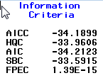
Table 8.10, Information Criteria of Δ log(CCI) with Δlog(HSI), Δlog(Liquidity), ΔCPI and Δlog(Prime Rate) under VAR(1) Model

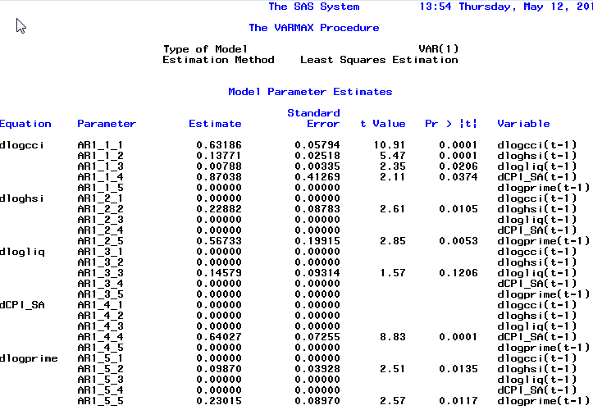
Table 8.11, Result of Δ log(CCI) with Δlog(HSI), Δlog(Liquidity), ΔCPI and Δlog(Prime Rate) under VAR(1) Model

Below are corresponding Information Criteria (Table 8.12) and the result of VAR(2) (Table 8.13)
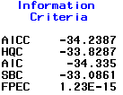
Table 8.12, Information Criteria of Δ log(CCI) with Δlog(HSI), Δlog(Liquidity), ΔCPI and Δlog(Prime Rate) under VAR(2) Model
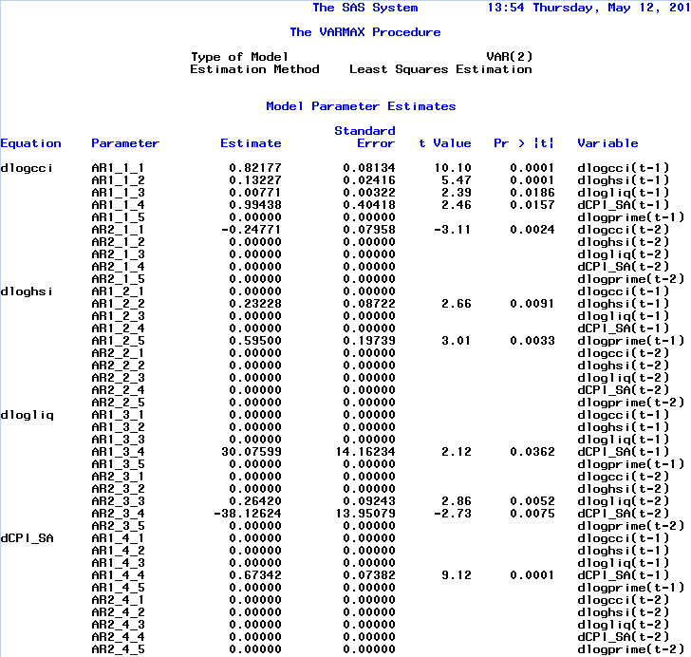
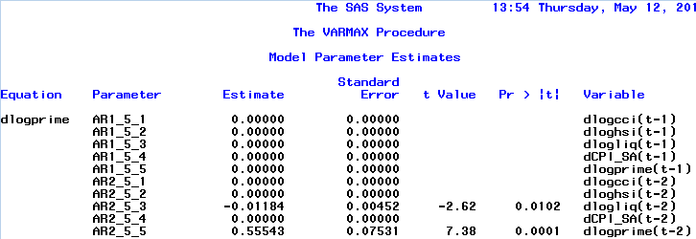
Table 8.13, Result of Δ log(CCI) with Δlog(HSI), Δlog(Liquidity), ΔCPI and Δlog(Prime Rate) under VAR(2) Model
Interpretation

From the two results we see that Δlog(HSI), Δlog(Liquidity), Δlog(Prime Rate) and ΔCPI itself related its 1st -lagged terms.

This model is more accurate by using AIC and BIC criteria.

In these two models, VAR(1) is not suggested since all coefficients of Δlog(Liquidity) are not significant.

Combined Finding

We study the VAR(2) model of Δlog(CCI) with Δlog(HSI), Δlog(Liquidity), ΔCPI and Δlog(Prime Rate) since the AIC and BIC value are the lowest

Δlog(CCI) = 0.82177 *Δlog(CCI_{t-1}) + 0.13227 * Δlog(HSI_{t-1}) + 0.00771 * Δlog(Liquidity_{t-1}) + 0.99438 * ΔCPI _{t-1} – 0.24771 * Δlog(CCI_{t-2}) +a1_{t}

Δlog(HSI) = 0.23228 * Δlog(HSI_{t-1}) + 0.595 * Δlog(Prime Rate_{t-1}) +a2_{t}

Δlog(Liquidity) = 30.07599 * ΔCPI_{t-1} + 0.2642 * Δlog(Liquidity_{t-1}) – 38.12624 * ΔCPI_{t-1} +a3_{t}

ΔCPI = 0.67342 * ΔCPI_{t-1} +a4_{t}

Δlog(Prime Rate) = -0.01184 * Δlog(Liquidity_{t-2}) + 0.55543 * Δlog(Prime Rate_{t-2}) +a5_{t}

- Adding Constant term does not help since the intercept coefficient is not significant
- Δlog(HSI), Δlog(Liquidity), ΔCPI following its 1st -legged term.
- Δlog(CCI) following its 1st and 2nd -legged term.
- Δlog(Prime Rate) does not directly affecting Δlog(CCI), it is just affecting Δlog(HSI) and then Δlog(HSI) affecting Δlog(CCI) slighting
- In decreasing order of importance, ΔCPI, Δlog(HSI), Δlog(Liquidity) are affecting Δlog(CCI)

9. CONCLUSION

The trend of our house prices is one the hottest topics in town. The property prices of Hong Kong have surged so much in the past two years. In this project, The monthly change of CCI (Δlog(CCI)) is used as the indicator of housing prices. Different candidate of housing price determinants were examined. Some terms are financial factors (HSI, bank prime rate, HIBOR, DXY, and liquidity) and the others are economic factors (GDP and CPI). The relationship of among these factors and housing prices are studied with multivariate autoregressive model (VAR). It is found that Δlog(CCI) can be fitted with VAR(2) model as follows:

Δlog(CCI_{t}) = 0.82177 Δlog(CCI_{t-1}) + 0.13227 Δlog(HSI_{t-1}) + 0.00771 Δlog(Liquidity_{t-1}) + 0.99438 ΔCPI _{t-1} – 0.24771 Δlog(CCI_{t-2}) +a1_{t}

Obviously, the change of CCI does not depend on a single factor. In short, the housing price is affected by its pervious values, stock market performance (HSI), local money liquidity, local inflation (CPI). As a conclusion, this project is an initial attempt to apply time series analysis to Hong Kong housing prices so as to find out the reasons why our properties becomes so expensive. The model is far from perfect and more investigations may be done in future.

Forecasting
It shows that the model shows mean-reverting to 0 after 12 months
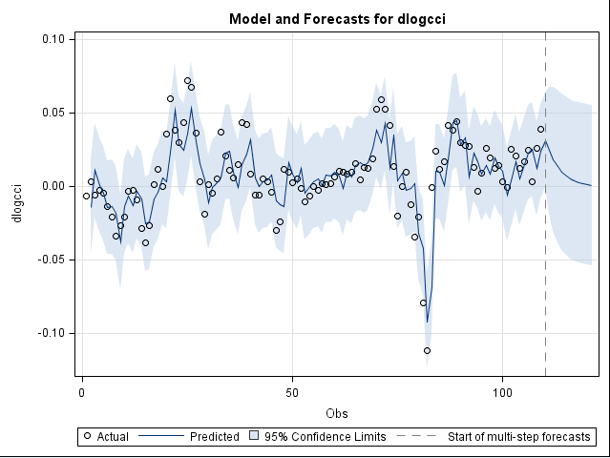
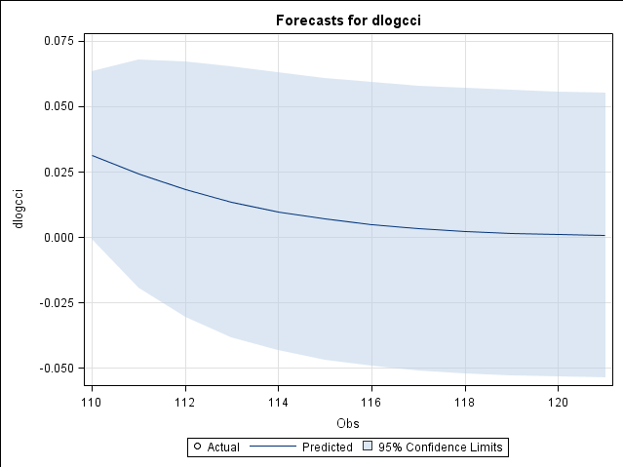

Appendix A – Output of CCI

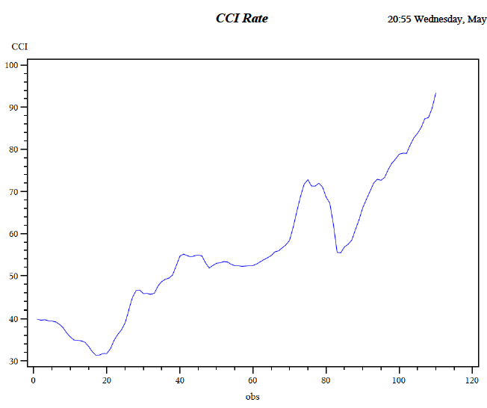

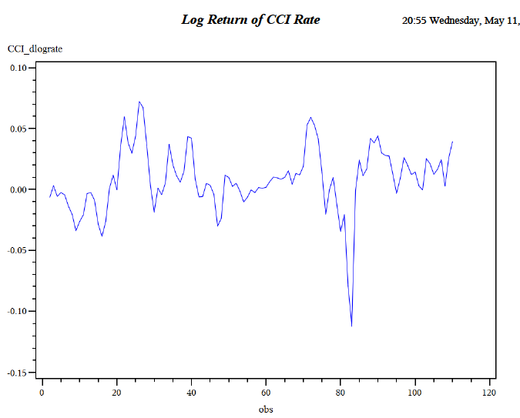

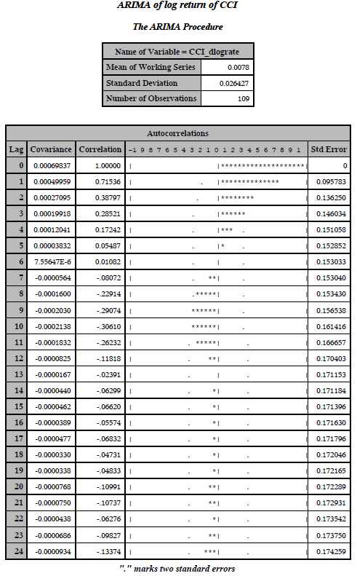

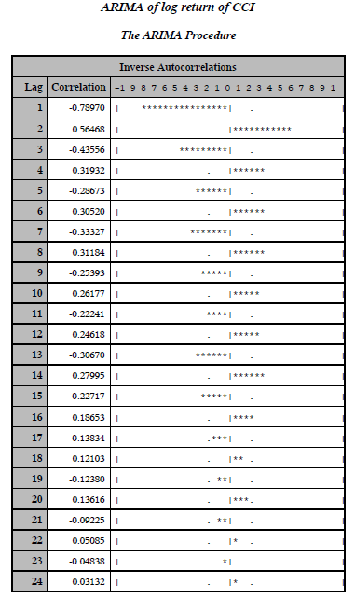

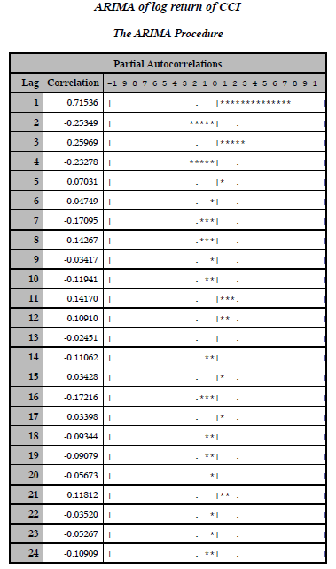

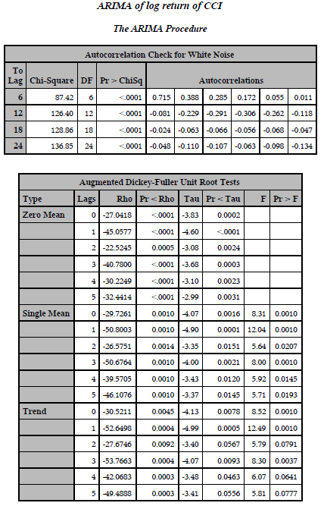

Appendix B – Output of Aggregate Balance

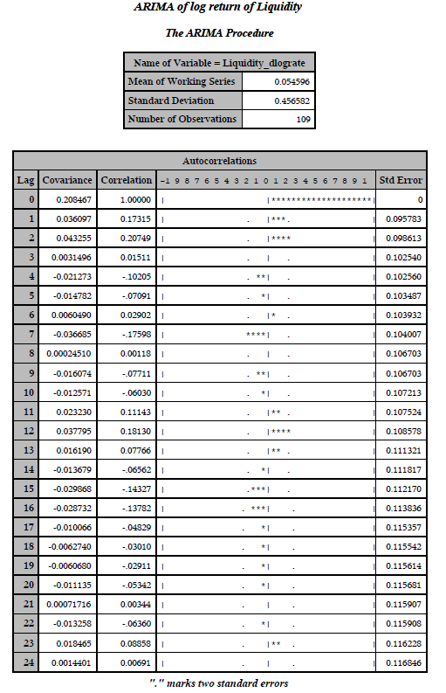
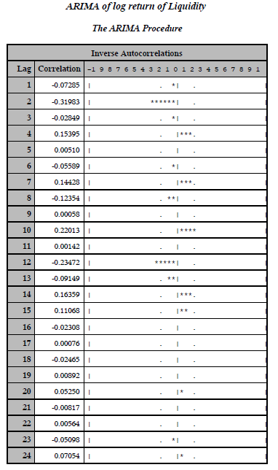
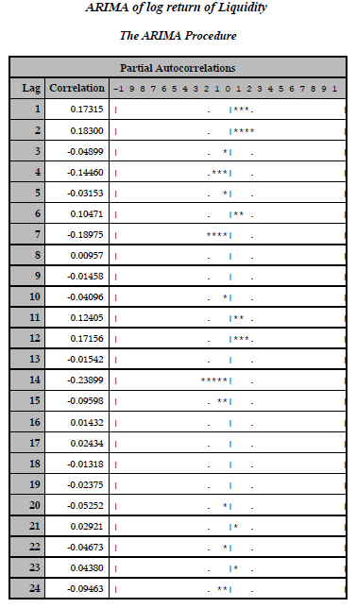
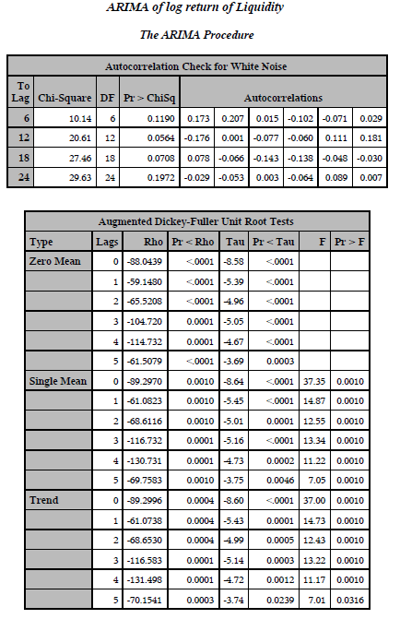
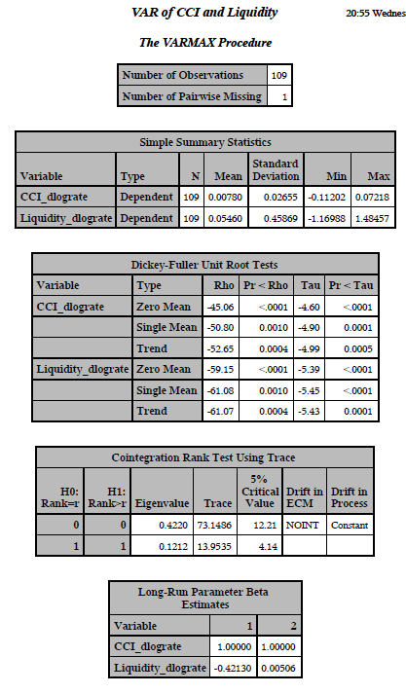

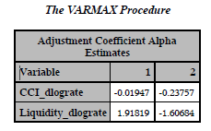

Appendix C – SAS output of interest rates

Appendix D – Output of US Dollar Index

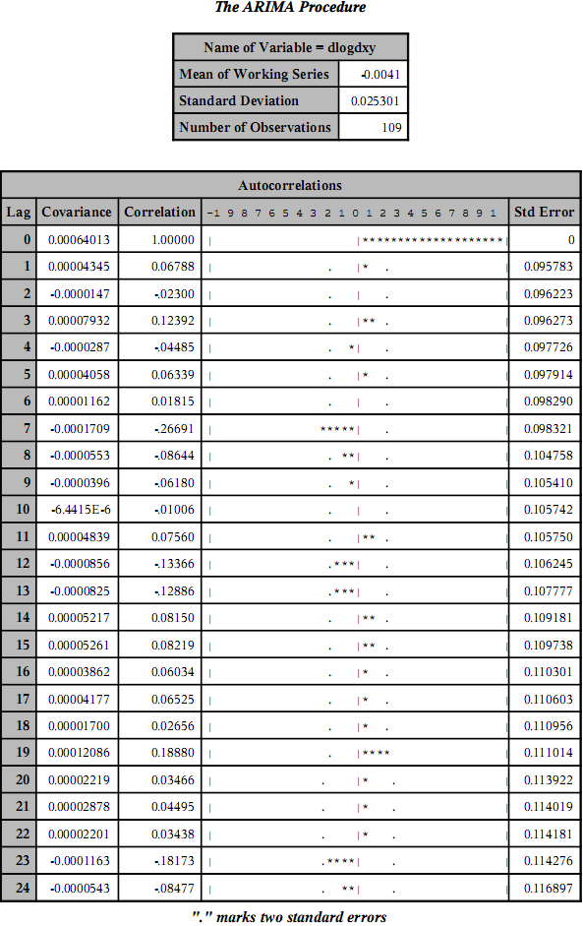

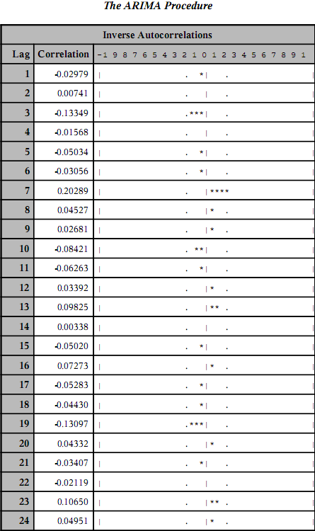

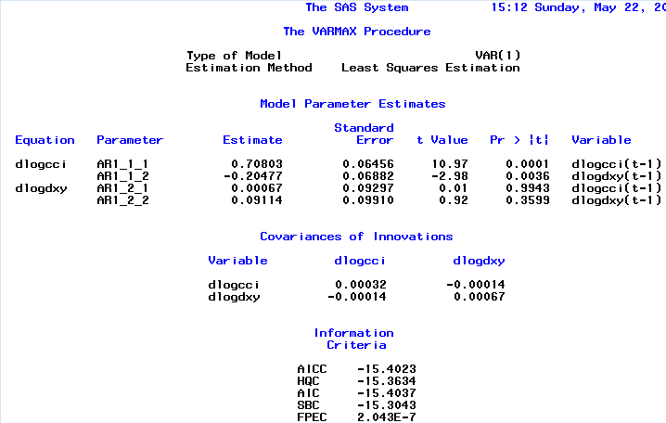

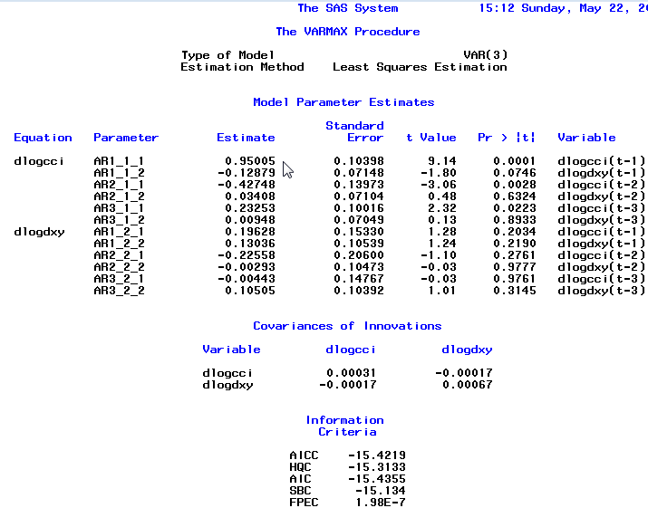
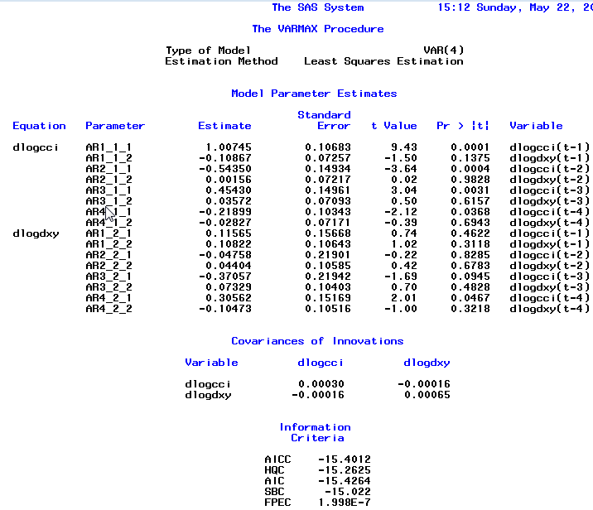

Appendix E – Output of HSI

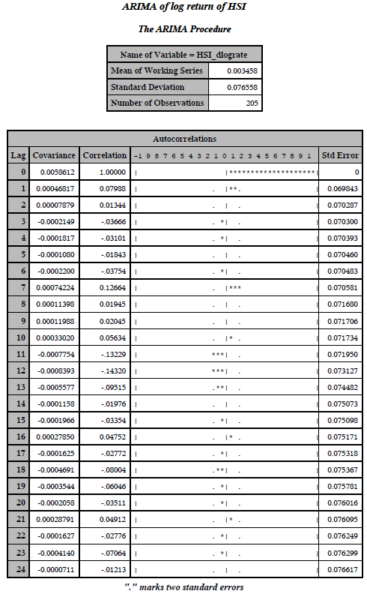
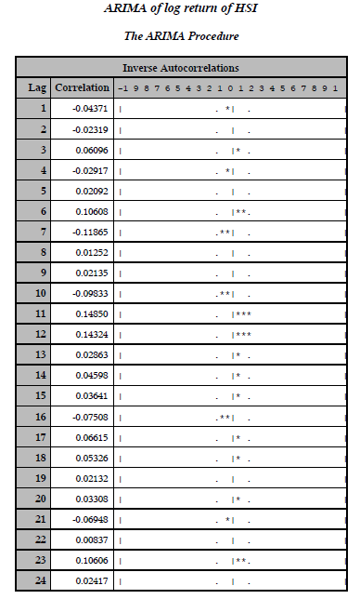
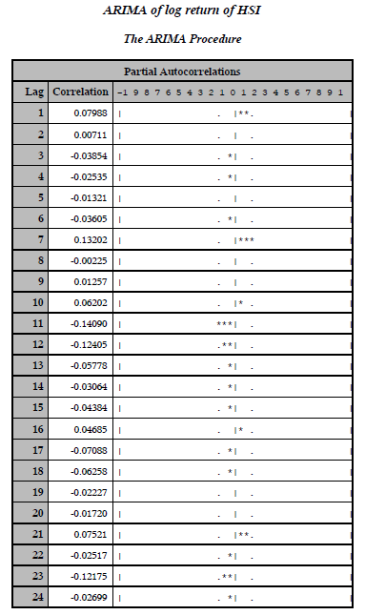
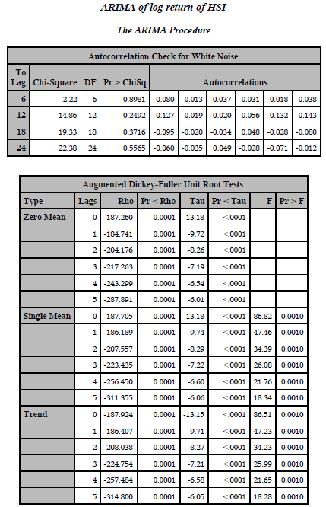
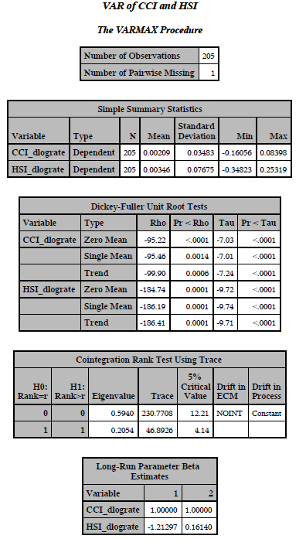

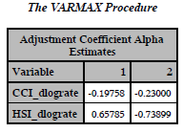

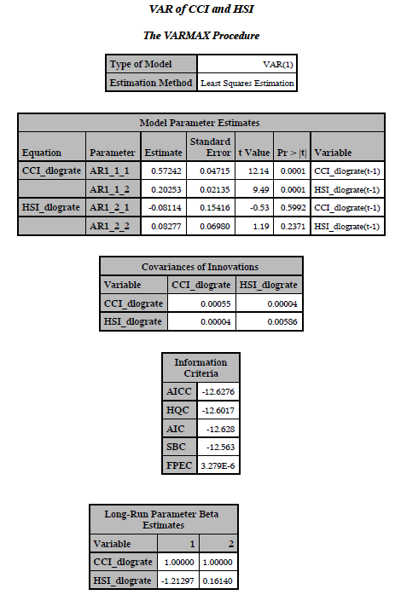

Appendix F– Output of CPI

Please note that all analysis in this appendix was done with software R

F.1 Unit root test of dCCI_SA

###############################################
# Augmented Dickey-Fuller Test Unit Root Test #
###############################################

Test regression trend

Call:
lm(formula = z.diff ~ z.lag.1 + 1 + tt + z.diff.lag)

Residuals:
Min 1Q Median 3Q Max
-0.007677 -0.001007 -0.000023 0.001141 0.010789

Coefficients:
Estimate Std. Error t value Pr(>|t|)
(Intercept) 5.511e-04 4.078e-04 1.351 0.178
z.lag.1 -2.491e-01 4.991e-02 -4.991 1.31e-06 ***
tt -2.015e-06 3.272e-06 -0.616 0.539
z.diff.lag1 6.820e-02 7.212e-02 0.946 0.345
z.diff.lag2 1.004e-01 7.081e-02 1.418 0.158
---
Signif. codes: 0 ‘***’ 0.001 ‘**’ 0.01 ‘*’ 0.05 ‘.’ 0.1 ‘ ’ 1

Residual standard error: 0.002687 on 199 degrees of freedom
Multiple R-squared: 0.1161, Adjusted R-squared: 0.09835
F-statistic: 6.536 on 4 and 199 DF, p-value: 5.822e-05

Value of test-statistic is: -4.9906 8.3724 12.557

Critical values for test statistics:
1pct 5pct 10pct
tau3 -3.99 -3.43 -3.13
phi2 6.22 4.75 4.07
phi3 8.43 6.49 5.47

F.2 Try VAR(4) and VAR(10)

VAR(4)

VAR Estimation Results:
=======================

Estimated coefficients for equation dCCI:
=========================================
Call:
dCCI = dCCI.l1 + dCPI_SA2.l1 + dCCI.l2 + dCPI_SA2.l2 + dCCI.l3 + dCPI_SA2.l3 + dCCI.l4 + dCPI_SA2.l4 + const + trend

dCCI.l1 dCPI_SA2.l1 dCCI.l2 dCPI_SA2.l2 dCCI.l3 dCPI_SA2.l3 dCCI.l4 dCPI_SA2.l4 const trend
5.776411e-01 1.620937e-01 -5.461119e-02 4.341743e-01 4.370895e-02 5.659871e-01 2.618469e-02 -1.171913e+00 -3.440888e-03 4.038199e-05

Estimated coefficients for equation dCPI_SA2:
=============================================
Call:
dCPI_SA2 = dCCI.l1 + dCPI_SA2.l1 + dCCI.l2 + dCPI_SA2.l2 + dCCI.l3 + dCPI_SA2.l3 + dCCI.l4 + dCPI_SA2.l4 + const + trend

dCCI.l1 dCPI_SA2.l1 dCCI.l2 dCPI_SA2.l2 dCCI.l3 dCPI_SA2.l3 dCCI.l4 dCPI_SA2.l4 const trend
2.485397e-03 8.513917e-01 9.490647e-03 1.235813e-02 -3.714551e-03 -4.986011e-01 7.566897e-03 4.938359e-01 2.021919e-04 -3.933766e-07

> summary(CCI.CPI.var4)

VAR Estimation Results:
=========================
Endogenous variables: dCCI, dCPI_SA2
Deterministic variables: both
Sample size: 201
Log Likelihood: 1378.125
Roots of the characteristic polynomial:
0.9063 0.8179 0.8179 0.8083 0.7255 0.4421 0.4421 0.3138
Call:
VAR(y = CCI.CPI, p = 4, type = "both")

Estimation results for equation dCCI:
=====================================
dCCI = dCCI.l1 + dCPI_SA2.l1 + dCCI.l2 + dCPI_SA2.l2 + dCCI.l3 + dCPI_SA2.l3 + dCCI.l4 + dCPI_SA2.l4 + const + trend

Estimate Std. Error t value Pr(>|t|)
dCCI.l1 5.776e-01 7.089e-02 8.149 4.72e-14 ***
dCPI_SA2.l1 1.621e-01 7.549e-01 0.215 0.830
dCCI.l2 -5.461e-02 8.193e-02 -0.667 0.506
dCPI_SA2.l2 4.342e-01 9.620e-01 0.451 0.652
dCCI.l3 4.371e-02 8.207e-02 0.533 0.595
dCPI_SA2.l3 5.660e-01 9.597e-01 0.590 0.556
dCCI.l4 2.618e-02 7.065e-02 0.371 0.711
dCPI_SA2.l4 -1.172e+00 7.551e-01 -1.552 0.122
const -3.441e-03 4.483e-03 -0.768 0.444
trend 4.038e-05 3.617e-05 1.116 0.266
---
Signif. codes: 0 ‘***’ 0.001 ‘**’ 0.01 ‘*’ 0.05 ‘.’ 0.1 ‘ ’ 1

Residual standard error: 0.02782 on 191 degrees of freedom
Multiple R-Squared: 0.364, Adjusted R-squared: 0.334
F-statistic: 12.15 on 9 and 191 DF, p-value: 4.184e-15

Estimation results for equation dCPI_SA2:
=========================================
dCPI_SA2 = dCCI.l1 + dCPI_SA2.l1 + dCCI.l2 + dCPI_SA2.l2 + dCCI.l3 + dCPI_SA2.l3 + dCCI.l4 + dCPI_SA2.l4 + const + trend

Estimate Std. Error t value Pr(>|t|)
dCCI.l1 2.485e-03 5.941e-03 0.418 0.676
dCPI_SA2.l1 8.514e-01 6.327e-02 13.456 < 2e-16 ***
dCCI.l2 9.491e-03 6.867e-03 1.382 0.169
dCPI_SA2.l2 1.236e-02 8.063e-02 0.153 0.878
dCCI.l3 -3.715e-03 6.878e-03 -0.540 0.590
dCPI_SA2.l3 -4.986e-01 8.044e-02 -6.199 3.43e-09 ***
dCCI.l4 7.567e-03 5.921e-03 1.278 0.203
dCPI_SA2.l4 4.938e-01 6.329e-02 7.803 3.86e-13 ***
const 2.022e-04 3.757e-04 0.538 0.591
trend -3.934e-07 3.032e-06 -0.130 0.897
---
Signif. codes: 0 ‘***’ 0.001 ‘**’ 0.01 ‘*’ 0.05 ‘.’ 0.1 ‘ ’ 1

Residual standard error: 0.002332 on 191 degrees of freedom
Multiple R-Squared: 0.7188, Adjusted R-squared: 0.7056
F-statistic: 54.25 on 9 and 191 DF, p-value: < 2.2e-16

Covariance matrix of residuals:
dCCI dCPI_SA2
dCCI 7.74e-04 5.980e-07
dCPI_SA2 5.98e-07 5.437e-06

Correlation matrix of residuals:
dCCI dCPI_SA2
dCCI 1.000000 0.009219
dCPI_SA2 0.009219 1.000000

VAR(10)
VAR Estimation Results:
=========================
Endogenous variables: dCCI, dCPI_SA2
Deterministic variables: both
Sample size: 195
Log Likelihood: 1370.895
Roots of the characteristic polynomial:
0.9714 0.9198 0.9198 0.9114 0.9114 0.8999 0.8999 0.8985 0.8985 0.8776 0.8776 0.8749 0.8749 0.8289 0.8289 0.8284 0.8284 0.7914 0.7914 0.7838
Call:
VAR(y = CCI.CPI, p = 10, type = "both")

Estimation results for equation dCCI:
=====================================
dCCI = dCCI.l1 + dCPI_SA2.l1 + dCCI.l2 + dCPI_SA2.l2 + dCCI.l3 + dCPI_SA2.l3 + dCCI.l4 + dCPI_SA2.l4 + dCCI.l5 + dCPI_SA2.l5 + dCCI.l6 + dCPI_SA2.l6 + dCCI.l7 + dCPI_SA2.l7 + dCCI.l8 + dCPI_SA2.l8 + dCCI.l9 + dCPI_SA2.l9 + dCCI.l10 + dCPI_SA2.l10 + const + trend

Estimate Std. Error t value Pr(>|t|)
dCCI.l1 5.803e-01 7.483e-02 7.755 7.29e-13 ***
dCPI_SA2.l1 -3.021e-01 9.710e-01 -0.311 0.7561
dCCI.l2 -9.259e-02 8.686e-02 -1.066 0.2879
dCPI_SA2.l2 1.195e+00 1.312e+00 0.911 0.3637
dCCI.l3 6.974e-02 8.739e-02 0.798 0.4260
dCPI_SA2.l3 -7.222e-02 1.296e+00 -0.056 0.9556
dCCI.l4 4.138e-02 8.745e-02 0.473 0.6367
dCPI_SA2.l4 -1.552e+00 1.379e+00 -1.125 0.2621
dCCI.l5 1.293e-02 8.670e-02 0.149 0.8816
dCPI_SA2.l5 1.524e+00 1.563e+00 0.975 0.3308
dCCI.l6 4.103e-03 8.634e-02 0.048 0.9622
dCPI_SA2.l6 -1.202e+00 1.571e+00 -0.765 0.4455
dCCI.l7 5.735e-02 8.440e-02 0.679 0.4977
dCPI_SA2.l7 1.227e-01 1.401e+00 0.088 0.9304
dCCI.l8 -4.806e-02 8.496e-02 -0.566 0.5723
dCPI_SA2.l8 7.086e-01 1.331e+00 0.532 0.5951
dCCI.l9 1.118e-02 8.461e-02 0.132 0.8951
dCPI_SA2.l9 -3.154e-01 1.337e+00 -0.236 0.8138
dCCI.l10 -1.757e-01 7.356e-02 -2.389 0.0180 *
dCPI_SA2.l10 4.112e-01 9.906e-01 0.415 0.6785
const -6.435e-03 4.924e-03 -1.307 0.1930
trend 6.290e-05 3.923e-05 1.603 0.1107
---
Signif. codes: 0 ‘***’ 0.001 ‘**’ 0.01 ‘*’ 0.05 ‘.’ 0.1 ‘ ’ 1

Residual standard error: 0.02804 on 173 degrees of freedom
Multiple R-Squared: 0.4099, Adjusted R-squared: 0.3382
F-statistic: 5.721 on 21 and 173 DF, p-value: 1.474e-11

F.3 Granger causality test of VAR(4)
$Granger

Granger causality H0: dCPI_SA2 do not Granger-cause dCCI

data: VAR object CCI.CPI.var4
F-Test = 0.831, df1 = 4, df2 = 382, p-value = 0.506
Appendix G – Output of GDP

Please note that all analysis in this appendix was done with software R

G.1 Unit root test on dGDP

###############################################
# Augmented Dickey-Fuller Test Unit Root Test #
###############################################

Test regression none

Call:
lm(formula = z.diff ~ z.lag.1 - 1 + z.diff.lag)

Residuals:
Min 1Q Median 3Q Max
-0.028318 -0.004212 0.004165 0.009436 0.071208

Coefficients:
Estimate Std. Error t value Pr(>|t|)
z.lag.1 -3.943e-01 1.376e-01 -2.866 0.00567 **
z.diff.lag1 -2.693e-01 1.488e-01 -1.810 0.07519 .
z.diff.lag2 -5.726e-06 1.265e-01 0.000 0.99996
---
Signif. codes: 0 ‘***’ 0.001 ‘**’ 0.01 ‘*’ 0.05 ‘.’ 0.1 ‘ ’ 1

Residual standard error: 0.01631 on 62 degrees of freedom
Multiple R-squared: 0.3214, Adjusted R-squared: 0.2885
F-statistic: 9.786 on 3 and 62 DF, p-value: 2.246e-05

Value of test-statistic is: -2.8658

Critical values for test statistics:
1pct 5pct 10pct
tau1 -2.6 -1.95 -1.61

G.2 Fit VR(1)

VAR Estimation Results:
=======================

Estimated coefficients for equation dCCI_Q:
===========================================
Call:
dCCI_Q = dCCI_Q.l1 + dGDP_SA.l1 + const + trend

dCCI_Q.l1 dGDP_SA.l1 const trend
0.1203982456 2.0368472797 -0.0349194761 0.0006441533

Estimated coefficients for equation dGDP_SA:
============================================
Call:
dGDP_SA = dCCI_Q.l1 + dGDP_SA.l1 + const + trend

dCCI_Q.l1 dGDP_SA.l1 const trend
9.669923e-03 2.708484e-01 3.959115e-03 6.927846e-05

VAR Estimation Results:
=========================
Endogenous variables: dCCI_Q, dGDP_SA
Deterministic variables: both
Sample size: 66
Log Likelihood: 265.402
Roots of the characteristic polynomial:
0.3549 0.03639
Call:
VAR(y = CCI.GDP, p = 1, type = "both")

Estimation results for equation dCCI_Q:
=======================================
dCCI_Q = dCCI_Q.l1 + dGDP_SA.l1 + const + trend

Estimate Std. Error t value Pr(>|t|)
dCCI_Q.l1 0.1203982 0.1193360 1.009 0.31694
dGDP_SA.l1 2.0368473 0.6495597 3.136 0.00262 **
const -0.0349195 0.0198870 -1.756 0.08404 .
trend 0.0006442 0.0004974 1.295 0.20011
---
Signif. codes: 0 ‘***’ 0.001 ‘**’ 0.01 ‘*’ 0.05 ‘.’ 0.1 ‘ ’ 1

Residual standard error: 0.07626 on 62 degrees of freedom
Multiple R-Squared: 0.248, Adjusted R-squared: 0.2117
F-statistic: 6.817 on 3 and 62 DF, p-value: 0.0004808

Estimation results for equation dGDP_SA:
========================================
dGDP_SA = dCCI_Q.l1 + dGDP_SA.l1 + const + trend

Estimate Std. Error t value Pr(>|t|)
dCCI_Q.l1 9.670e-03 2.490e-02 0.388 0.6991
dGDP_SA.l1 2.708e-01 1.355e-01 1.998 0.0501 .
const 3.959e-03 4.150e-03 0.954 0.3437
trend 6.928e-05 1.038e-04 0.668 0.5069
---
Signif. codes: 0 ‘***’ 0.001 ‘**’ 0.01 ‘*’ 0.05 ‘.’ 0.1 ‘ ’ 1

Residual standard error: 0.01591 on 62 degrees of freedom
Multiple R-Squared: 0.1014, Adjusted R-squared: 0.05789
F-statistic: 2.331 on 3 and 62 DF, p-value: 0.08286

Covariance matrix of residuals:
dCCI_Q dGDP_SA
dCCI_Q 0.0058159 0.0004729
dGDP_SA 0.0004729 0.0002532

Correlation matrix of residuals:
dCCI_Q dGDP_SA
dCCI_Q 1.0000 0.3897
dGDP_SA 0.3897 1.0000

G.3 Diagnoistics of model VAR(1)

Portmanteau Test (asymptotic)
Q16
data: Residuals of VAR object CCI.GDP.var1
Chi-squared = 46.9961, df = 60, p-value = 0.8894

var1.norm <-normality.test(CCI.GDP.var1)
> var1.norm
$JB

JB-Test (multivariate)

data: Residuals of VAR object CCI.GDP.var1
Chi-squared = 38.5992, df = 4, p-value = 8.429e-08

$Skewness

Skewness only (multivariate)

data: Residuals of VAR object CCI.GDP.var1
Chi-squared = 8.7404, df = 2, p-value = 0.01265

$Kurtosis

Kurtosis only (multivariate)

data: Residuals of VAR object CCI.GDP.var1
Chi-squared = 29.8588, df = 2, p-value = 3.283e-07

Appendix H – Output of Combined Model
Here we only included the model significant result, VAR(2) model of Δlog(CCI) with Δlog(HSI), Δlog(Liquidity), ΔCPI and Δlog(Prime Rate)

